**FSLA: FILIPINO SIGN LANGUAGE APPLICATION**

A Capstone

Presented to the Faculty of the College of Computing Studies

Don Honorio Ventura State University

In Partial Fulfilment

Of the Requirements for the Degree

Bachelor of Science in Information Technology

By:

January 2022

**APPROVAL SHEET**



**MARIA IVY M. GUSES, MIT**

Academic/Technical Adviser

**THESIS COMMITTEE**

**JOEL D. CANLAS, MIT, MBA**

Chair

**JULIETA M. UMALI, MSIT, MAIE**

Co-Chair

**ASIL KASTLE S. DELA CRUZ, MIT** **MARIA IVY M. GUESE, MIT**

Member Member

# EDEN D. GARCIA, MIT

Member

**PANEL OF EXAMINERS**

Accepted and approved in partial fulfillment of the requirements for the Degree of

Bachelor of Science in **Information Technology**

**JOEL D. CANLAS, MIT, MBA**

College Dean

**ACKNOWLEDGEMENT**

Foremost, praise and thanks be to God, the Almighty for His blessings during our study to ensure that the research is completed effectively. We would like to express our deep and sincere gratitude to our Capstone 2 professor, Ms. Julieta M. Umali, for allowing us to undertake research and for providing us with invaluable support during the writing of this paper. We would also like to express our deep and sincere gratitude to our research advisor, Maria Ivy M. Guese, for her support and guidance and also to her invaluable time spent guiding us through the process of completing the research. We are extremely grateful to our parents for their love, understanding, prayers, caring and sacrifices for educating and preparing us for our future. We also want to thank them for their constant encouragement in helping us finish our study. Finally, we want to express our gratitude to everyone who assisted us in

accomplishing the work in the field of research, either directly or indirectly.

**Table of Contents**

Title Page .......................................................................................................................1

Approval Sheet...............................................................................................................2

Acknowledgement .........................................................................................................3

Table of Contents ...........................................................................................................4

List of Tables .................................................................................................................6

List of Figures ................................................................................................................6

Abstract ..........................................................................................................................8

Introduction ....................................................................................................................9

Statement of the Problem .................................................................................12

Objectives of the Study ....................................................................................13

Scope and Delimitations ..................................................................................13

Target Respondents and Locale .......................................................................14

Significance of the Study .................................................................................14

Methodology ................................................................................................................15

Planning ...........................................................................................................16

Analysis............................................................................................................17

Designing .........................................................................................................17

Development ....................................................................................................17

Testing..............................................................................................................17 Implementation ................................................................................................18 Maintenance .....................................................................................................18

Research Method .............................................................................................18

Research Design ..............................................................................................19

Research Instruments .......................................................................................19

Questionnaire .......................................................................................19

Interview ..............................................................................................20

Respondents of the Study.................................................................................21

Sampling Technique ............................................................................22

Data Analysis .......................................................................................22

Result and Discussion ..................................................................................................23

Discussion ....................................................................................................................33

Conclusion ............................................................................................................34

Recommendation ..................................................................................................35

References ....................................................................................................................36

Appendices ...................................................................................................................38

Appendix A: Title Defense and Evaluation Result Form .....................................38

Appendix B: Gannt Chart .....................................................................................40

Appendix C: Screenshots of Proposed System.....................................................43

Appendix D: Entity Related Diagram ..................................................................53

Appendix E: Preliminary Questions .....................................................................55

Appendix F: Post-Survey Questionnaire (Proposed System) ...............................58 Appendix G: Letter of Request to Conduct a Study .............................................62

Appendix H: Academic Adviser Request Letter ..................................................64

Appendix I: System Code .....................................................................................65

**List of Tables**

Table 1: Number of Respondents ................................................................................21

Table 2: Likert Scale ....................................................................................................23

Table 3: Post Evaluation Questionnaire for Abled Individuals ...................................26

Table 4: Post Evaluation Questionnaire for Deaf Individuals .....................................27

Table 5: Post Evaluation Questionnaire for Mute Individuals.....................................29

Table 6: Post Evaluation Questionnaire for Deaf and Mute Individuals .....................31

**List of Figures**

Figure 1: System Development Life Cycle ..................................................................16

Figure 2: Evaluation Form ...........................................................................................39

Figure 3: Gannt Chart ..................................................................................................40

Figure 4: Starting Page.................................................................................................44

Figure 4.1: User Input Page .........................................................................................45

Figure 4.2: Home Page ................................................................................................46

Figure 4.3: Word of the Day ........................................................................................47

Figure 4.4: Let’s Learn New Words ............................................................................48

Figure 4.5: Games ........................................................................................................49 Figure 4.6: Links/Stories ..............................................................................................50

Figure 4.7: Feedbacks ..................................................................................................51

Figure 4.8: Slide Bar ....................................................................................................52

Figure 5: Entity Relationship Diagram ........................................................................53

Figure 6: Preliminary Questionnaire ............................................................................55

Figure 7: Post Survey (Proposed System) Questionnaire ............................................58

Figure 7: Letter of Request to Conduct a Study ..........................................................62

**ABSTRACT**

This study aims to develop an application that could help the deaf and mute persons communicate properly. Each user will comprehend what are the vital words or phrases through sign language. The general objective of this system is to implement an application that can be used by individuals who are hearing impaired, mute, and abled person. Various research, documents, papers, interviews, and questionnaires have been checked and performed to collect the evidence needed for the analysis. The interview was performed by face-to-face or virtual questioning for the deaf, mute, and abled individuals. Because of the actual consultations with them, the researchers became more knowledgeable of what they should accomplish and what significant things they need to be improved. Application is the most tough to do by researchers because it is manageable to use by people with this disorder. This application has a part where users can practice, learn, and recognize every sign language they play. People surveyed said the application is easy to use, understand, and not complicated when used. Majority of the respondents are satisfied with the developed system. The FSLA application will remarkably help deaf or mute people who have learned another sign language such as ASL.

# INTRODUCTION

In today’s century, the development of technology is continuously growing and improving and can be considered as a significant part of our day to day life. One of the technologies greatest contribution in our society is the improvement of communication. Communication is known as the way on how two person or group understand each other and the way of expressing thoughts and ideas through words and actions. Communication is composed of 3 basics categories; the verbal communication, nonverbal communication, and written communication *(“What are the 3 types of communication”, 2019).*

Now a day’s people have variety of methods in communicating with others, from a simple talk personally to communicating through the use of technologies (e.g computers, cellphones, tablets, etc.). It is the way of spreading knowledge and information. Additionally, communication is the principle of all human relationship. Human have five senses; sense of sight through eyes, smell through nose, taste through tongue, touch through the skin, and the sense of hear through ears. Commonly people communicate by means of using their sense of hearing. However, there are cases where this sense is lost or weakened, it can be due to birth defect, from hereditary, accidents or just by simply aging. Those people who are deaf from birth are considered as mute, because they cannot learn how to speak without being able to hear (Meimban et al.,

2019).

According to a conducted census that is subjected for the percentage/numbers of person with disabilities of National Statistical Office (known as Philippine Statistical

Office today), it is an organization handled by the Philippine Government. There are 942, 098 persons living in the

Philippines who have disabilities, representing to 8.1% of the total population in both hearing and speaking impaired and there are 1.2% or 76, 731 of the population have a disability in hearing itself only (Meimban et al., 2019).

Jean Karl M.G (2014) stated that the Deaf people existence has been recorded in the early 2000 BC in Egypt, and they were also mentioned in Greece and Rome where the perspective on them were discriminatory in nature. Deaf and mute people in the society have had a long history of discrimination, wherever they go in the world.

They were always view as ‘weird’ or ‘strange’, not being capable to be fully understood and an outcast to those abled people. Most deaf and mute worldwide grow up without having a proper language to use to communicate with others. There are some cases where their family member develops a rudimentary sign, also called as ‘home signs’, and this is what they usually use to communicate with their relatives, but these are not the actual sign languages which cannot be used as way of communicating with other people. Deafness is increasingly being recognized not only as an urgent disability issue but also a linguistic problem (Liberty Notarte-Balanquit, 2021).

Deaf and mute people connect among other individuals by means of sign language. Sign Language helps deaf and mute people express their thoughts and ideas through a variety of hand gestures, body movement and facial expressions. And the most common sign language that they know and used is the American Sign Language

(ASL). But ASL is not the native language of the Philippines, this is where Filipino Sign Language (FSL) introduced.

In a study written by Liberty Notarte-Balanquit (2021) stated that there has been a recent development in the recognition of the Filipino Sign Language as the national visual-gestural language in the Philippines through the R.A. 11106 or the FSL Act of 2018. Because of this, it widens the academic discourse on deafness and especially, it opened an opportunity for FSL to develop well and be recognized not only as a natural language of deaf and mute but also as a language system inherent and crucial in shaping the Deaf and Mute Identity.

However, there are still people who doesn’t know or doesn’t have enough knowledge when it comes to FSL and can have a hard time communicating with others. Because not all people have the capability on going to a school or hire a tutor in order to learn FSL, one of the key factors is that they’re not financially stable. In a related study written by Garcia, M.G. et al (2016) they developed an application (app) which goal is to present an interactive experience with deaf users.

They’re main tutorial lesson provided in their app is the Filipino Sign Language (FSL). They’re application contains three modules: dictionary, illustrations and assessments.

The researchers also admire to develop such application that can help deaf and mute persons in learning the Filipino Sign Language in an easy and fun way with the additional and new features to be developed.

The researchers aimed to develop an application named “FSL: U Speak!”

provides the basic Filipino Sign Language for free, a tutorial on how to do the proper hand gesture and body movements, that can help not only those people with hearing and speech impairment but also the abled persons who are interested to learn Filipino Sign Language.

# General Problem

People around the world use different languages to communicate with each other. For deaf and mute people, sign language has always been an effective way to express what they want to communicate. However, there is still difficulty in communication with deaf-mute people without understanding their sign language.

# Specific Problem

1. What are the means to communicate properly to deaf?
2. Is there a medium to communicate to the deaf?
3. Is there an application that can used to learn and understand Filipino Sign Language?

4.

# General Objectives

The proponents would like to develop an application that helps on how to communicate with deaf and mute people. This is to instruct them about the Filipino Sign Language so that they will have an adequate understanding when it comes to sign languages. This application will serve as the voice of every hearing and voice impaired. Those who seek to learn or to those beginners can learn the basic sign language. By using this app, people with or without disabilities will both benefit; those with disabilities will be competent to communicate well and those abled individuals will gain new knowledge.

The developers have specifically considered the following objectives to integrate the following main feature in the said system. First, there will be a user input page. Second, the words and phrases are categorized so that the user will be able to use the application easily. Third, there are mini games for the assessment of the user and lastly, there are related stories to watch for the users’ additional knowledge.

# Scope and Delimitations

The overall intent of this study is to assist DEAF and MUTE Filipinos in learning Filipino Sign Language (FSL). That can help Deaf-Mute and other interested people to communicate using our native language as their sign language, so that they can easily understand each other. The application provides three modules: FSL

Dictionary, Illustration and Assessment.

Program of Filipino Sign Language Application (FSL)

1. Simple and easy to use the FSL Application
   1. No need to register/sign In, so that the user can access easily.
   2. Interesting games for the user assessment.
2. Persuade the user to download and use the FSL Application.

The researcher limits the study to 60 participants from San Fernando, Pampanga who caters deaf and mute citizens and also abled individuals. There are about 10 participants who are deaf and mute, 15 who are deaf only, 5 who are mute only, and 30 who are abled individuals for a total of 60 respondents. The researcher conducts an interview for each of the respondents.

# Target Respondents and Locale

The target respondents of the study is the citizens from Sanfernando, Pampanga. Expecting to have 60 (sixty) persons as respondents of this study.

The study will be conducted in San Fernando, Pampanga. The respondents will answer the survey questionnaires on places they are comfortable. The survey questionnaires will be sent through email.

# Significance of the Study

**Deaf and Mute Individuals.** This study would address deaf and mute individual in learning Filipino Sign Language (FSL) instead of asl and use it primarily as a medium of communication among other people. This study can also help them so that they can easily talk to others without any hesitation.

**Deaf People's Relatives.** They can communicate with them like how families used to.

**Community.** The study will help the community in understanding those individuals with hearing and speaking disability by their own accord. This will cater everyone in the community, not only those who have deaf or mute individual in their family. **Future researchers.** The future researchers may use this research as their guidance to gather information. This will also serve as a building blocks for thorough study in the future.

**The Researcher.** The researchers will be able to improve their skill, strategy, and knowledge with regards to research.

# METHODOLOGY

In this study, the researcher selects the System Development Life Cycle

(SDLC) to be used during the development of the system. The System Development Life Cycle (SDLC) is a methodology that has distinct defined processes for building high-quality software. The SDLC is a method for evaluating and improving the development process. It enables a fine-grained examination of each process stage. In the Figure 1 shown below the phases of the SDLC are Planning, Analysis, Designing, Development and Testing, Implementation, and Maintenance (G.

Jevtic, 2019).

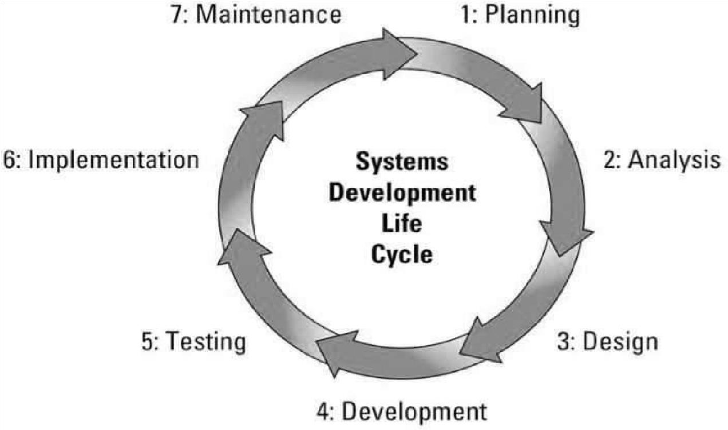

Figure 1: ***System Development Life Cycle (Pavel Kukhnavets, 2019)***

# Planning

Due to COVID – 19 Pandemic, the researchers are making a time to meet the other members to talk about the said study and to brainstorm different ideas regarding the development of the system. They came up with the issue of challenges faced by deaf and mute individuals and picked San Fernando, Pampanga as their locale. Through the use of Google

Meet, the researchers are able to make a plan about the study which is the FSLA: Filipino Sign Language Application. The researchers planned to make a great sign language application for the deaf and mute people and also for the abled individuals who have interest in learning FSL, so that they will have a clear understanding to each other.

# Analysis

The researchers will determine the information about Filipino Sign

Language, system’s functions, and system requirements. The system will provide the information gathered by the researchers about Filipino Sign Language to deaf-mute and non-deaf-mute. The system will be having an English to Filipino and Filipino to English sign language translation. The researchers will also provide a comparison of the existing application.

# Designing

Based on the gathered information about FSL, the researchers came up with a user-friendly UI, unique design and features. For the software used to build the application, Android Studio is an application development tool where you can build apps for Android phone and tablets. For the requirements of the FSL android application, it can be access through any android devices.

# Development

The development for the prototype of the application is based on the previous phase. By using the design and features provided in designing phase, the researchers will generate a prototype using Android Studio that can be tested through different android versions and devices.

# Testing

For the testing phase, the researchers will test the developed prototype application in order to identify errors and bugs. If errors or bugs is encountered, this will be fixed until every function is not followed as planned. The application will be tested through different android versions and devices.

# Implementation

In the implementation phase, the application constructed by the programmer and designer will be available for the end user. The system will continue to be tested until the requirements are not met on the design phase.

# Maintenance

After the FSL android application is in full operation. The researchers may apply software upgrades, repairs, version upgrades, and fixes of the application if it breaks. Monitoring the performance of the FSL android application is also included during the maintenance phase.

# Research Methods

The researcher's study entitled FSLA: Filipino Sign Language Application is a Qualitative Research. Qualitative Research is generally a nonnumeric data. With the qualitative research, it has data from the online interview and survey that will be conducted by the researchers for the deaf-mute people. The study is qualitative research because the researchers gathered some information from deafmute and non-deaf and mute people based on their opinions and experiences.

# Research Design

The study is a Descriptive Research based on the information gathered by the researchers. Descriptive Research described a situation or a phenomenon. It can also answer the what, when, where and how questions except why questions. The researchers asked the target respondents what, where, when and how questions based on their real-life experiences. The purpose of descriptive studies is to know the individual's experiences and to describe the phenomenon and its characteristics. Based on the study, the researchers need to know or learn the characteristics and different experiences of the non-deaf and mute people especially the deaf-mute people.

# Research Instruments

The research instruments used by the researchers are online interview and questionnaire. Due to COVID - 19 Pandemic, the researchers conducted an online interview instead of face to face interview. The online interview and questionnaires were made in the Google Form and sent it to the target respondents.

# Questionnaire

The researcher used a web-based form via Google form that served as the questionnaire for the study. All the questionnaire was designed in a close-ended style. Questionnaires were sent to deaf-mute and abled persons via messenger and answered with the supervision of the researchers.

The following are considered and asked on the respondents to know their insights and suggestions about the developed system:

|  |  |
| --- | --- |
| * Functional Suitability * Compatibility * Usability | * Performance Efficiency * Reliability * Security |

# Interview

Due to COVID - 19 pandemic, the researchers conducted an online interview. The focus of the interview will be on how deaf-mute and non-deaf-mute can understand each other and how will they communicate. The initial interview will determine the problem encountered by those deaf-mute and abled people in communicating with each other without knowing sign language. The researchers will suggest a potential solution to the issues they are currently experiencing. The researcher will propose the system to a deaf-mute and abled person in a follow-up interview.

Following are the major reason of the researchers to conduct an interview:

* To know the best on how to learn sign language
* To determine the reasons why some of the deaf-mute people do not know

Filipino

Sign Language.

* To determine what is the best way to learn Filipino Sign Language.

# Respondents of the Study

The researchers will be following certain conditions to know who will be include in their respondents: 1) The respondents are deaf and mute people 2) the respondents are the nondeaf and non-mute persons. The purpose of the questionnaire distribution was to learn the current approach of the communication between deaf-mute and non-deaf-mute. As shown in table 1, the number of respondents is ten (10) deaf-mute people, ten (10) deaf only, ten (10) mute only and ten (10) abled people, for a total of 40 respondents.

# Table 1

|  |  |
| --- | --- |
| **Respondents** | **Number of Respondents** |
| Deaf and Mute | 10 |
| Deaf only | 15 |
| Mute only | 5 |
| Abled Individuals | 30 |

Total No. of Respondents 60

# Sampling Method

Snowball was used in the study. Through this method, the researcher identified the deafmute and abled person as the appropriate respondent for the study. The snowball are the characteristics of networking and referral. The researchers usually start with a small number of initial respondents who fit the research standard and who might be willing participants themselves, who would then refer additional potential respondents, and so on (Carlie Parker et al., as cited in Paul Atkinson et al. 2019).

# Data Analysis

This technique decides the requirement and expectation of the client. The researcher used a questionnaire to be able to know the effectiveness of their existing process on how to communicate with others.

# Table 2 Likert Scale

|  |  |  |  |
| --- | --- | --- | --- |
| *Strongly Agree* | Value | Range |  |
| 5 | 4.20- 5.00 | |
| *Agree* | 4 | 3.40- 4.19 | |
| *Fair* | 3 | 2.60- 3.39 | |
| *Disagree* | 2 | 1.80- 2.59 | |
| *Strongly Disagree* | 1 | 1.00- 1.79 | |

A 5- point scale will be used to assess the user’s level of acceptance of the system and  the evaluation. (1) Strongly Disagree: (1.00-1.79); (2) Disagree: (1.80-2.59); (3) Fair: (2.60-3.39); (4) Agree: (3.40-4.19); (5) Strongly Agree: (4.20-5.00)



# Results and Discussions

In this chapter, the researchers present the results of their study. This section should present the findings of the research in a logical order, free of bias or interpretation. The researchers conducted an interview to specify the problems encountered by the deaf and mute individuals. Gathered data were from deaf and mute people and their relatives. For data analysis, percentage was utilized as statistical technique.

Based on the conducted interview, most of the deaf and mute individuals only know the American Sign Language (ASL), and some of them doesn't have proper knowledge in sign language. One of the reasons is that they did not attend to a school where they can learn sign language, according to them there are PWD schools who are free tuition but there are still miscellaneous fees that they need to pay and majority of them are experiencing financial difficulties, and most PWD schools only teach the American Sign Language.

For the initial phase, obtaining data records to aid in the system's conceptualization. It has been decided that a mobile application system is the most suitable medium to use since majority of the population use mobile phones; an application that has the capability to teach Filipino Sign Language. Words and phrases are categorized so that the user will be able to easily understand the features of the app and how it works.

In the beginning of the application, the get started page (see Appendix C, Figure 4) will show which contains the application logo and a button to proceed with the user name functionality (see Appendix C, Figure 4.1), the user will input their name in order to have a full access to the application. The main page of the system has the following buttons; word of the day, let’s learn new words, games, stories, and feedbacks (see Appendix C, Figure 4.2). When the user taps the “Word of the Day” button, it will show the different Filipino sign language words and phrases and every time the user taps the said button, the Filipino sign language videos appears randomly (see Appendix C, Figure 4.3). Next feature of the app is the “Let’s learn new words”. Inside this button there are list of different Filipino sign language to learn that are categorized (see Appendix C, Figure 4.4). All of the Filipino sign language demonstrated in the app are validated by a professional sign language teacher. The user’s learning progress in Filipino sign language can be assess by means of the game feature of the app (see Appendix C, Figure 4.5). Each video presented in the game has multiple choices to choose. When the user’s answer is correct, that will be equivalent to 10 points, but if the answer is incorrect there will be a 1point deduction to the score. Additionally, every time the user chose the wrong answer the choices will be shuffled. The application has limited content to learn, but the app has a feature where there are links to a specific video that are related to

Filipino sign language and that is the “Stories” feature (see Appendix C, Figure 4.6). Some of the videos selected in this app are stories about deaf and mute, so that the users will have additional knowledge about the deaf and mute community, also there are other video tutorials from YouTube influencers that share their skills when it comes to sign language. The user can also express their opinions by means of the “Feedback” feature of the app (see Appendix C, Figure 4.7). They can rate the app based on their satisfaction and can leave some comments and recommendations. A slide bar feature is added to the application where the user will see the logo of the app, the email address, and the user’s name (see Appendix C, Figure 4.9) and has 3 buttons; home, about and exit.

As we discussed to them about the proposed system, they said that they will be glad to be given the opportunity to use to the proposed system, and said that it will

help not only them but also their family, relatives and friends.

**Table 3**

# Post Evaluation Questionnaire for Abled Individuals

|  |  |  |  |  |  |
| --- | --- | --- | --- | --- | --- |
|  | | **Mean** | | **Descriptive Rating** | |
| **Functional** **Suitability**   1. Completeness of functionality. All of the functions and user goals are covered by the system. 2. Functional Accuracy. The technology produces accurate results the required accuracy. 3. Appropriateness in term of function. The method makes it easier to fulfill certain tasks and goals | | 4.3    4.1      4.7 | | Strongly Agree    Agree    Agree | |
| **Performance** **Efficiency**   1. Time Behavior. When   executing its duties, the system's response and processing times, as well as throughput rates, fulfill the criteria.   1. Resource utilization. The number and types of resources employed by the system to carry out its functions satisfy the specifications. 2. Capacity. The system's maximum parameter   limitations fulfill the requirement. | | 4.17            4.6          4.13 | | Agree            Strongly Agree          Agree | |
| **Compatibility**  1. Interoperability. The system is capable of exchanging information and using such information. | | 4.33 | | Strongly Agree | |
| **Usability**  1. Appropriateness  Recognizability. The system | |  | |  | |
| enables users to determine whether it is suitable for their requirements. | | 4.44 | | Strongly Agree | |
| **Reliability**   1. Maturity. In regular operation, the system satisfies the requirements for dependability. 2. Availability. When needed, the system is effective and accessible. 3. Fault Tolerance. Despite the presence of hardware or software flaws, the system performs as expected. 4. Recoverability. The system can restore the desired state and recover the data that was directly damaged. | | 4.5  4.44    4.33    4.7 | | Strongly Agree  Strongly Agree    Strongly Agree    Strongly Agree | |
| **Security**  1. Confidentiality. The system ensures that data is only available to those who have been granted access. | | 4.43 | | Strongly Agree | |

**Overall Mean** 4.34 Strongly Agree

Table 3 shows the evaluation results of abled users. They strongly agreed to its availability that the Filipino Sign Language Application is effective and accessible when needed with weighted mean 4.4. Likewise, the respondents agreed that the system performs as expected despite the presence of hardware or software flaws with weighted mean 4.33. The respondents are satisfied with the over-all application.

# Table 4

**Post Evaluation Questionnaire for Deaf Individuals**

**Mean**

**Descriptive Rating**

|  |  |  |  |  |  |
| --- | --- | --- | --- | --- | --- |
| **Functional Suitability**   1. Completeness of functionality. All of the functions and user goals are covered by the system. 2. Functional Accuracy. The technology produces accurate   results the required accuracy.   1. Appropriateness in term of function. The method makes it easier to fulfill certain tasks and goals | | 4.6    4.53      4.53 | | Strongly Agree    Strongly Agree    Strongly Agree | |
| **Performance Efficiency**   1. Time Behavior. When   executing its duties, the system's response and processing times, as well as throughput rates, fulfill the criteria.   1. Resource utilization. The number and types of resources employed by the system to carry out its functions satisfy the specifications. 2. Capacity. The system's maximum parameter   limitations fulfill the requirement. | | 4.4            4.8          4.47 | | Strongly Agree            Strongly Agree          Strongly Agree | |
| **Compatibility**  1. Interoperability. The system is capable of exchanging information and using such information. | | 4.33 | | Strongly Agree | |
| **Usability**  1. Appropriateness  Recognizability. The system enables users to determine whether it is suitable for their requirements. | | 4.53 | | Strongly Agree | |
| **Reliability**  1. Maturity. In regular operation, the system satisfies the requirements for dependability. | | 4.4 | | Strongly Agree | |
| 1. Availability. When needed, the system is effective and accessible. 2. Fault Tolerance. Despite the presence of hardware or software flaws, the system performs as expected. 3. Recoverability. The system can restore the desired state and recover the data that was directly damaged. | | 4.33    4.73    4.6 | | Strongly Agree    Strongly Agree    Strongly Agree | |
| **Security**  1. Confidentiality. The system ensures that data is only available to those who have been granted access. | | 4.6 | | Strongly Agree | |

**Overall Mean** 4.53 Strongly Agree

Table 4 shows the evaluation results of the deaf individuals. The individuals strongly agreed that the system has the functions and capability they expected. They also strongly agreed in the application’s confidentiality with the weighted mean 4.6.

# Table 5

**Post Evaluation Questionnaire for Mute Individuals**

|  |  |  |  |  |  |
| --- | --- | --- | --- | --- | --- |
|  | | **Mean** | | **Descriptive Rating** | |
| **Functional Suitability**   1. Completeness of functionality. All of the functions and user goals are covered by the system. 2. Functional Accuracy. The technology produces accurate   results the required accuracy.   1. Appropriateness in term of function. The method | | 3.6    4.4 | | Agree    Strongly Agree | |
| makes it easier to fulfill certain tasks and goals | | 4.2 | | Strongly Agree | |
| **Performance Efficiency**   1. Time Behavior. When   executing its duties, the system's response and processing times, as well as throughput rates, fulfill the criteria.   1. Resource utilization. The number and types of resources employed by the system to carry out its functions satisfy the specifications. 2. Capacity. The system's maximum parameter   limitations fulfill the requirement. | | 4.4            4.4          3.6 | | Strongly Agree            Strongly Agree          Agree | |
| **Compatibility**  1. Interoperability. The system is capable of exchanging information and using such information. | | 4 | | Agree | |
| **Usability**  1. Appropriateness  Recognizability. The system enables users to determinewhether it is suitable for their requirements. | | 4 | | Agree | |
| **Reliability**   1. Maturity. In regular operation, the system satisfies the requirements for dependability. 2. Availability. When needed, the system is effective and accessible. 3. Fault Tolerance. Despite the presence of hardware or software flaws, the system performs as expected. 4. Recoverability. The system can restore the desired state and recover the data that was directly damaged. | | 3.8  3.8    3.8    4 | | Agree  Agree    Agree    Agree | |

# Security

1. Confidentiality. The system 4.4 Strongly Agree ensures that data is only available to those who have been granted access. **Overall Mean**

4.03

Agree

Table 5 shows the evaluation results of the mute individuals towards the application. They agreed that despite the presence of hardware or software flaws, the system performs as expected with the weighted mean 3.8. They also agreed that the system enables users to determine whether it is suitable for their requirements with the weighted mean 4.

# Table 6

**Post Evaluation Questionnaire for Deaf and Mute Individuals**

|  |  |  |  |  |  |
| --- | --- | --- | --- | --- | --- |
|  | | **Mean** | | **Descriptive Rating** | |
| Functional Suitability   1. Completeness of functionality. All of the functions and user goals are covered by the system. 2. Functional Accuracy. The technology produces accurate   results the required accuracy.   1. Appropriateness in term of function. The method makes it easier to fulfill certain tasks and goals | | 3.9    4.9      4 | | Agree    Agree    Agree | |
| **Performance Efficiency**  1. Time Behavior. When  executing its duties, the system's response and processing times, as well as | | 4 | | Agree | |
| throughput rates, fulfill the criteria.   1. Resource utilization. The number and types of resources employed by the system to carry out its functions satisfy the specifications. 2. Capacity. The system's maximum parameter limitations fulfill the requirement. | | 4.4          3.9 | | Strongly Agree          Agree | |
| **Compatibility**  1. Interoperability. The system is capable of exchanging information and using such information. | | 3.7 | | Agree | |
| **Usability**  1. Appropriateness  Recognizability. The system enables users to determine whether it is suitable for their requirements. | | 3.9 | | Agree | |
| **Reliability**   1. Maturity. In regular operation, the system satisfies the requirements for dependability. 2. Availability. When needed, the system is effective and accessible. 3. Fault Tolerance. Despite the presence of hardware or software flaws, the system performs as expected. 4. Recoverability. The system can restore the desired state and recover the data that was directly damaged. | | 4.1  4.1    4.5    4 | | Agree  Agree    Strongly Agree    Agree | |
| **Security**  1. Confidentiality. The system ensures that data is only available to those who have been granted access. | | 4 | | Strongly Agree | |

**Overall Mean** 4.03 Agree

Table 6 shows the evaluation results of the deaf and mute individuals towards the application. They agreed with the time behavior of the application that when executing its duties, the system's response and processing times, as well as throughput rates, fulfill the criteria with the weighted mean 4.

# Discussion

The proposed study aims to encourage individuals who seek to study Filipino Sign Language in the strategy using an application especially now that there is a pandemic. We prevent having close contact with different people so it is favorable to study sign language if only at home, it is also good especially with individuals who have difficulties attending expensive schools for PWDs. Other apps with the same idea as sign language are heart-warming because it also helps other individuals.

Interviews and conducted questionnaires were used to better understand the broad functions of the system itself. Those who answered the questionnaires were mostly deaf and abled persons. Researchers can determine how they will come up with the proposed system. This is a key to helping the deaf/mute individuals to learn Filipino Sign Language.

In the results that emerged, the majority of the respondents agreed that there is potential to implement such an application. Majority of the respondents strongly agreed that they are satisfied with the developed system. The results from the proposed study provided positive feedback.

The deaf and mute community and also the abled persons gave a positive feedback on the results of the over-all application. They mentioned that having simple access to the application they require helps them to learn Filipino sign language.

Users said that it is not difficult to explore and use but a few said that they lack the features that have been installed. The application's features make it easier to comprehend and learn the Filipino sign language for users.

# Conclusion

Based on the survey accomplished by the researchers, it has reached numerous conclusions about Filipino Sign Language Application, the app where every speech and hearing impaired as well as abled individuals can learn Filipino Sign Language. The researcher’s primary conclusions are discussed below.

This application is developed to help the deaf and mute individuals learn the Filipino

Sign Language. With this, they will be able to learn and adapt to Filipino Sign Language and make it as their way of communication with others. The application is designed to have a mini game for the assessment of the user so that they can test if they truly learned and understood the different Filipino Sign Language.

The results show that having this application which has a capability to teach the

Filipino

Sign Language for free and found it efficient especially for those who don’t have any proper knowledge about Filipino Sign Language. In addition, this application is user-friendly because it will not take private information from the user. Therefore, the researcher concluded that the proposed study was able to help not only the deaf and mute individuals but also the abled persons to learn the Filipino Sign Language. **Recommendation**

Due to the limitation of the study, the researchers suggest the following features for the future use of other researchers.

1. Sign Language to voice translator
2. Put different activities or games that are organized for deaf/mute
3. Image/video to text (sensor) to translate the sign language that performed by the user
4. If possible, the theme can be changed. (The user decides what style, color, and tone depends on what they prefer).

**References:**

[1]Gaverza, J.K. (March 2014). An Analysis of Deaf Culture in the Philippines. Retrieved from [https://www.academia.edu/9793059/An_Analysis_of_Deaf_Culture_in_the_Philip](https://www.academia.edu/9793059/An_Analysis_of_Deaf_Culture_in_the_Philippines)

[pines.](https://www.academia.edu/9793059/An_Analysis_of_Deaf_Culture_in_the_Philippines)

[2]Goran Jevtic (2019). “What is the Development Life Cycle?” PhoenixNAP.

Retrieved from https://phoenixnap.com/blog/software-development-life-cycle

[3]Kuknhavets, P. (2019). 7 Stages of Software Development Life Cycle [diagram].

Retrieved from [https://welldoneby.com/blog/7-stages-of-software-development-lifecycle/](https://welldoneby.com/blog/7-stages-of-software-development-life-cycle/)

[4]Meimban, R.J., & Loresco, J. (2019). Development of Speech to Filipino Sign Language for the Deaf or Mute Filipinos Using Hidden Markov Model (HMM). *International journal of simulation: systems, science and technology*. Retrieved from

[https://edas.info/doi/10.5013/IJSSST.a.20.05.06.](https://edas.info/doi/10.5013/IJSSST.a.20.05.06)

[5]Nolker, C., H. Ritter. (2002). Visual Recognition of Continuous Hand Postures.

IEEE Trans. Neural Networks, 13(4), 983-994.

[6]Notarte-Balanquit, L. (2021). Insights from the First Filipino Sign Language

(FSL) Summit

& the Prospects for Filipino Sign Linguistics. Retrieved from

[https](https://www.researchgate.net/publication/349492274_Insights_from_the_First_Filipino%20Sign%20La)://www.researchgate.net/publication/349492274_Insights_from_the_First_Fi

lipino Sign [Language_FSL_Summit_February_20-](https://www.researchgate.net/publication/349492274_Insights_from_the_First_Filipino_Sign_Language_FSL_Summit_February_20-21_the_prospects_for_Filipino_sign_linguistics)

[21_the_prospects_for_Filipino_sign_linguistics.](https://www.researchgate.net/publication/349492274_Insights_from_the_First_Filipino_Sign_Language_FSL_Summit_February_20-21_the_prospects_for_Filipino_sign_linguistics)

[7]What are the 3 types of communication skills?”. *The Yellow Spot Blog*. (14 March, 2019). Retrieved from [https://theyellowspot.com/blogs/what-are-the-3types-of-communicationskills/](https://theyellowspot.com/blogs/what-are-the-3-types-of-communication-skills/)

[8]World Health Organization. "WHO global estimates on prevalence of hearing loss." Mortality and Burden of Diseases and Prevention of Blindness and Deafuess

Conference,

(2012). http:/[/www.who.intJpbd/deafuess/WHO GE](http://www.who.intjpbd/deafuess/WHO) HL.pdf. Last accessed on February 5, 2014.

# APPENDIX A

**(Title Defense and Evaluation Result Form)**

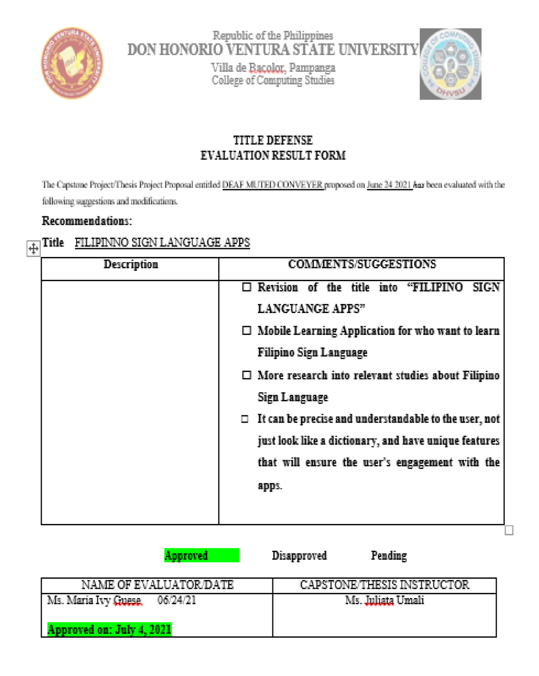

Figure 2. Evaluation Form

# APPENDIX B

**(Gantt Chart)**

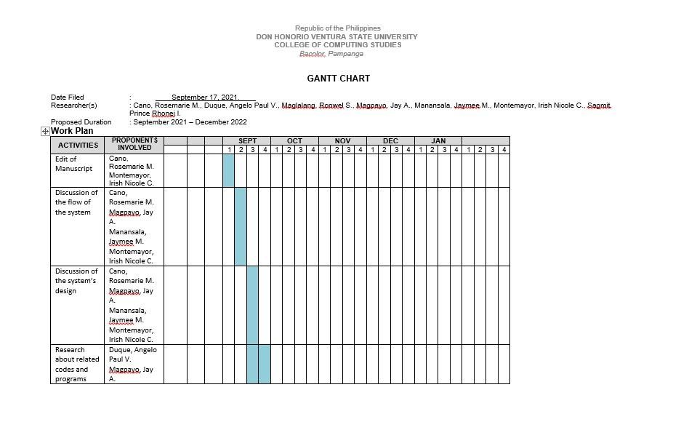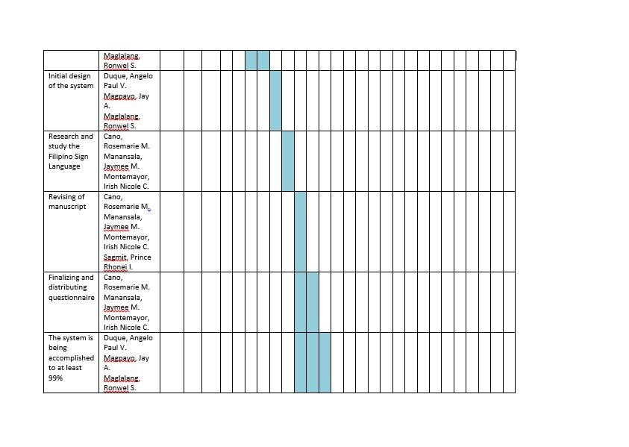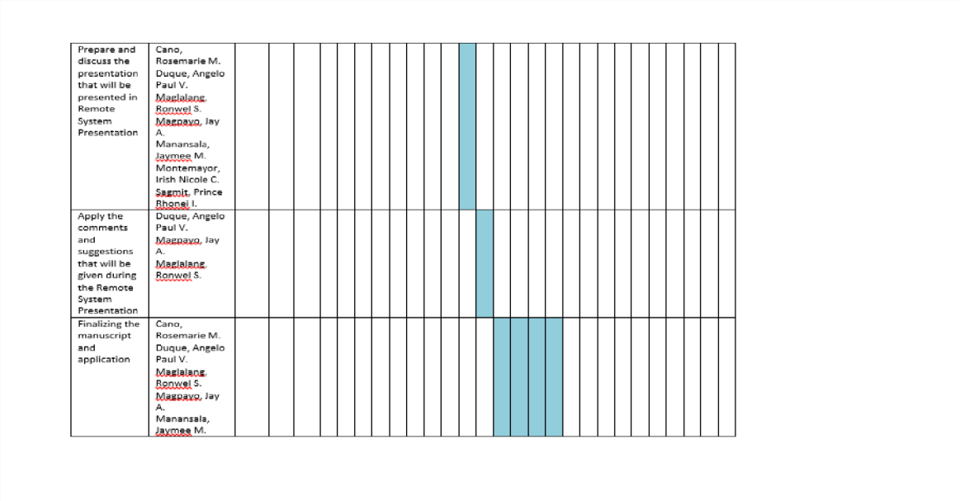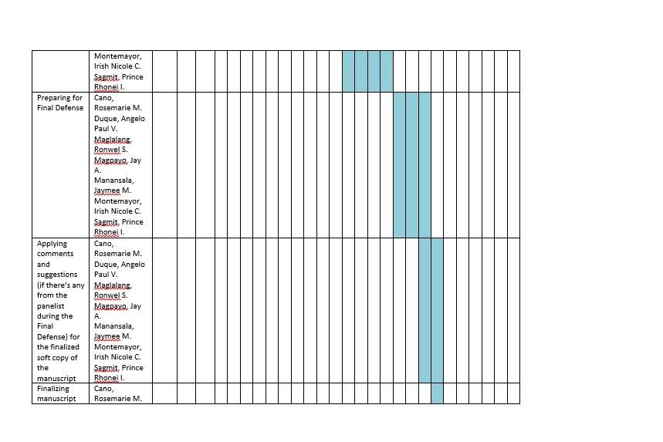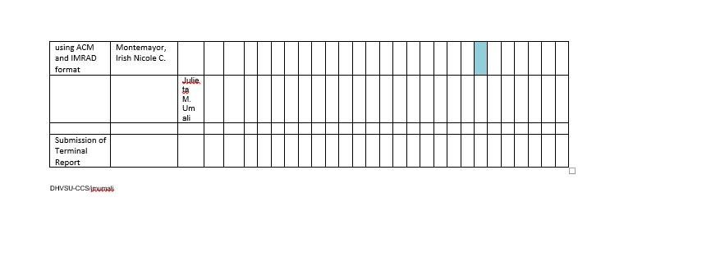

Figure 3: Gannt Chart

**APPENDIX C**

## (Screenshots of the Proposed System)

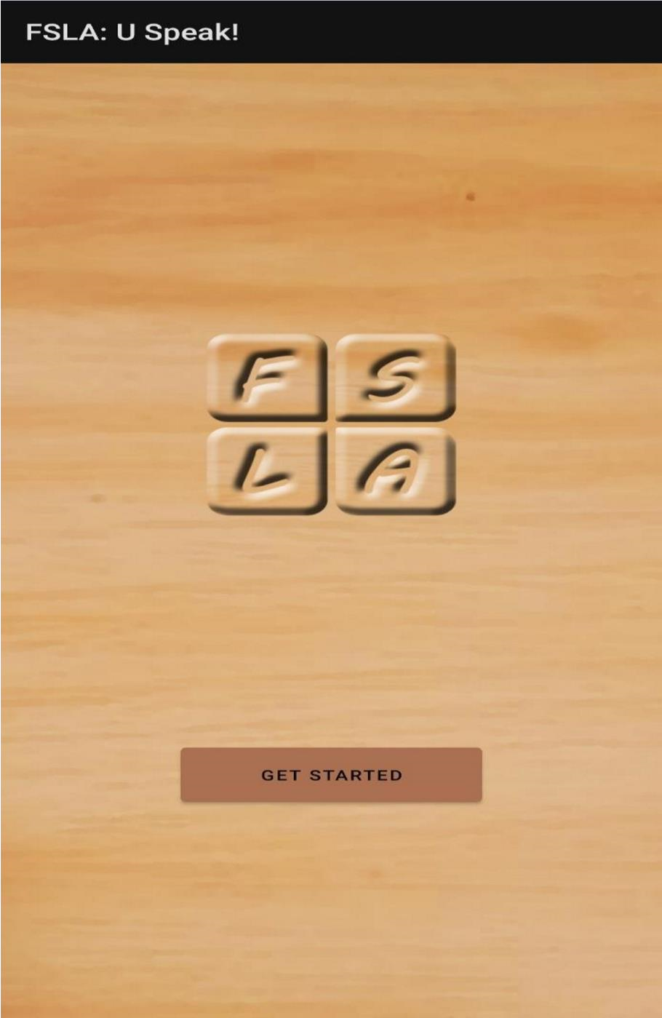

**Figure 4: Starting Page**

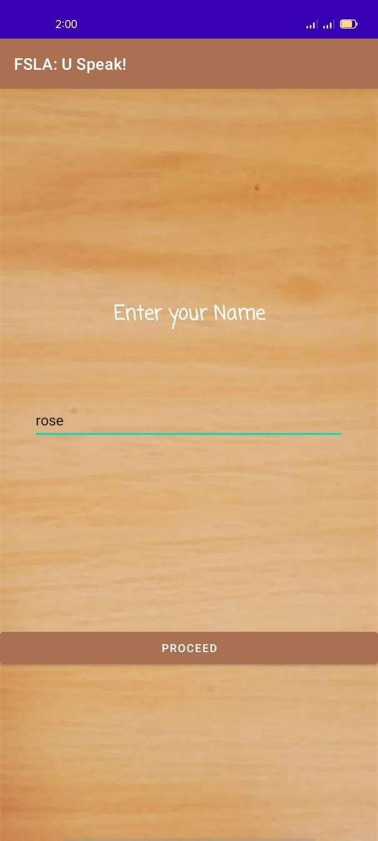

**Figure 4.1: User Input Page**

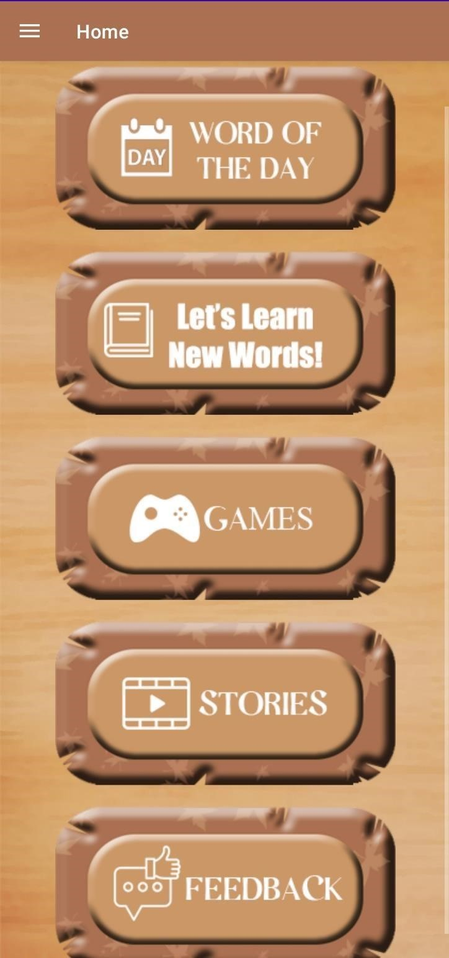

**Figure 4.2: Home Page**

### Figure 4.3: Word of the Day

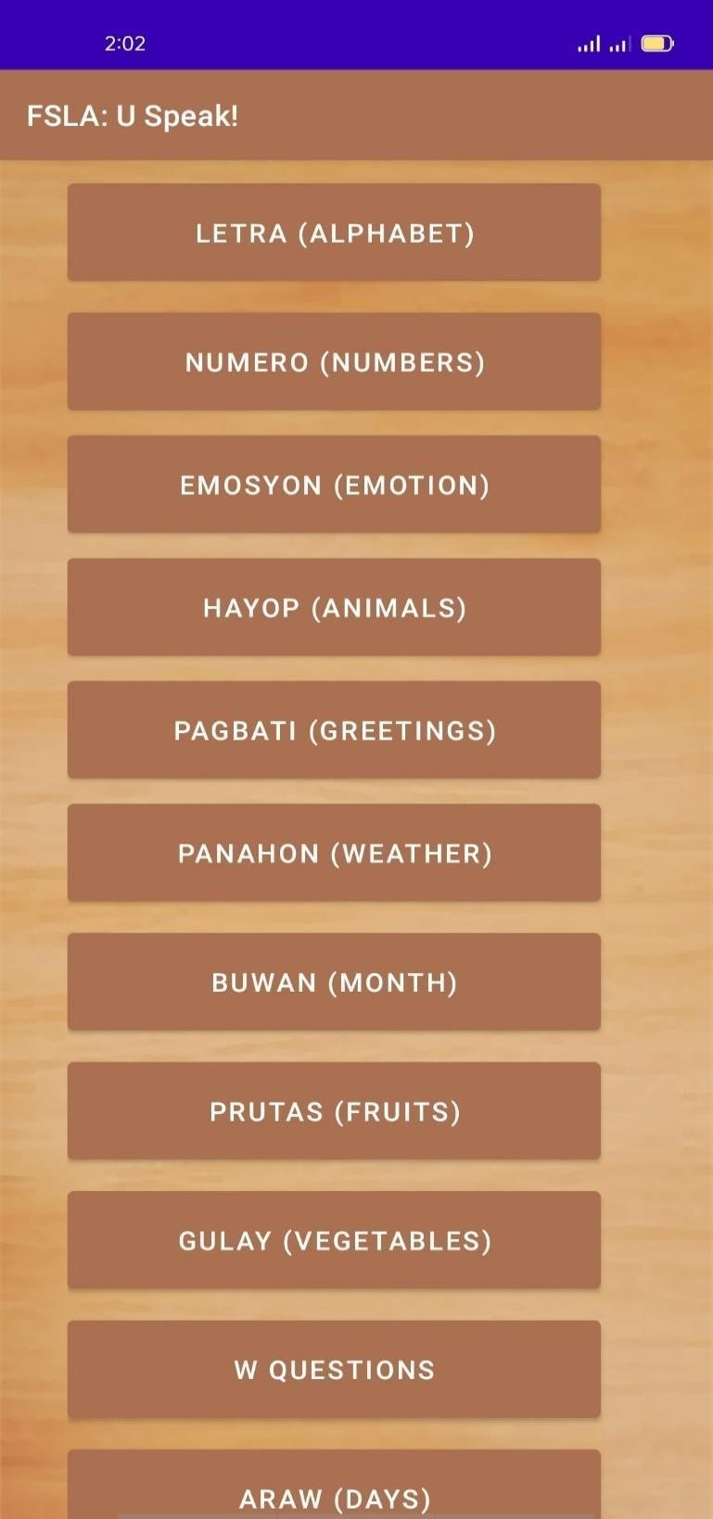

**Figure 4.4: Let’s Learn New Words**

### Figure 4.5: Games

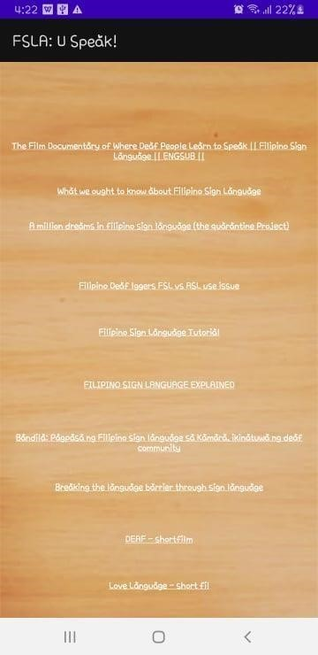

**Figure 4.6: Links/Stories**

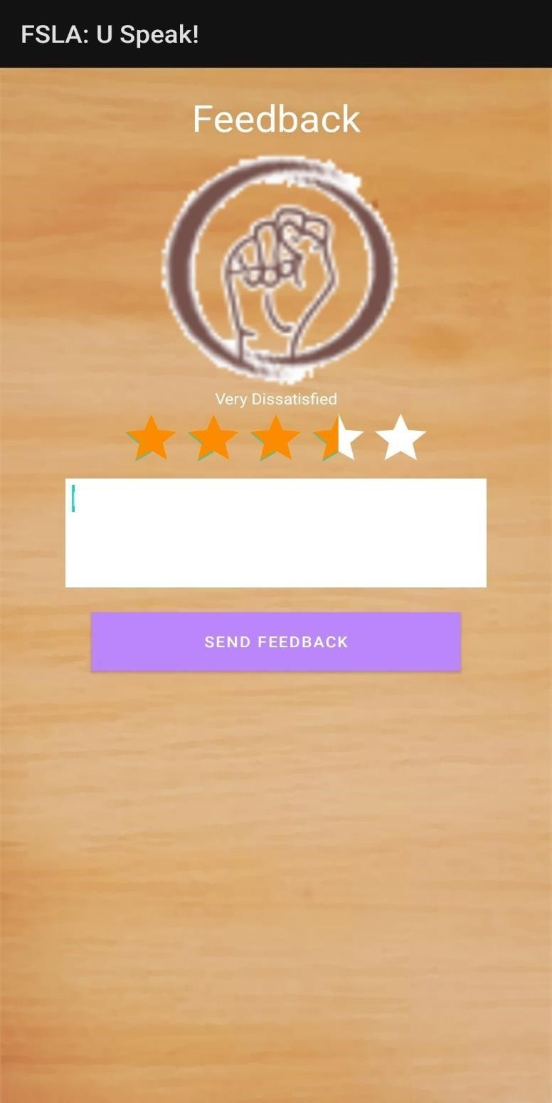

**Figure 4.7: Feedbacks**

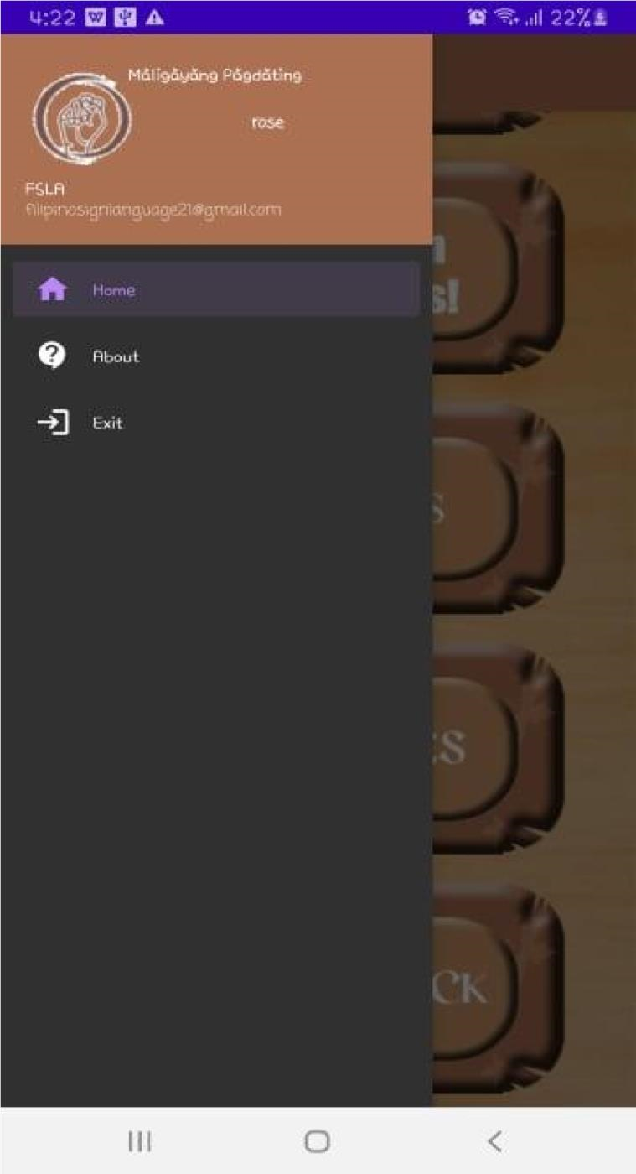

**Figure 4.8: Slide Bar**

# APPENDIX D

(Entity-Relationship Diagram)

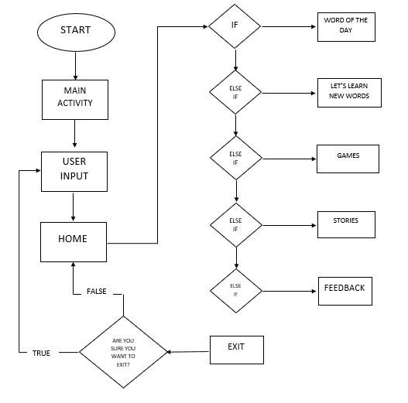

Figure 5 Entity-Relationship Diagram

# APPENDIX E

**(Preliminary Questionnaire)**

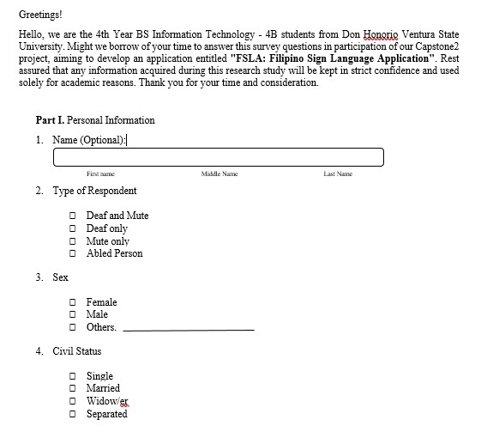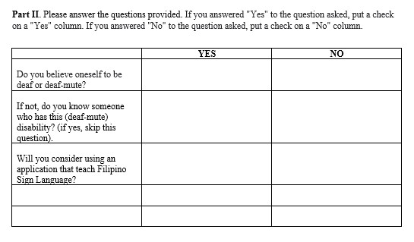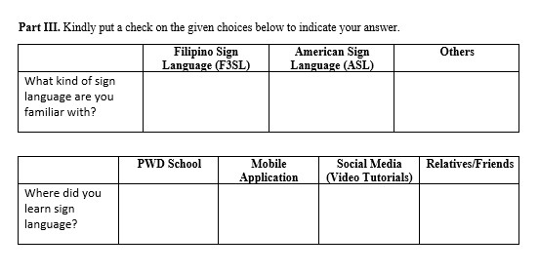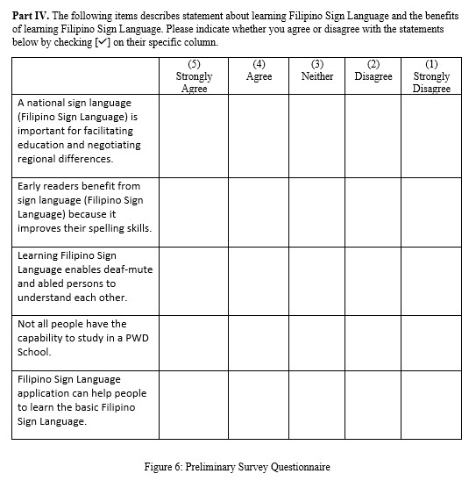

# APPENDIX F

## (Post Survey ((Proposed System))

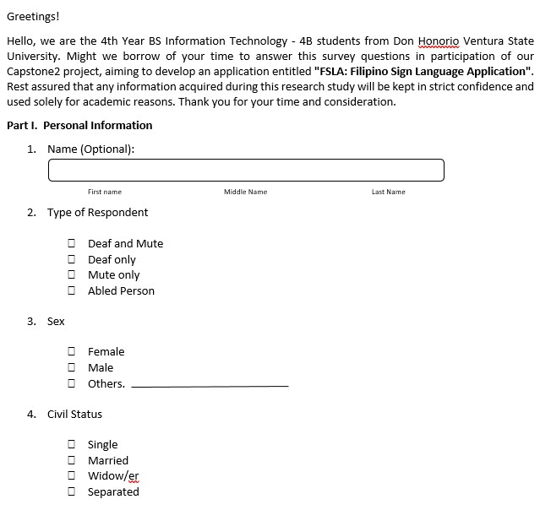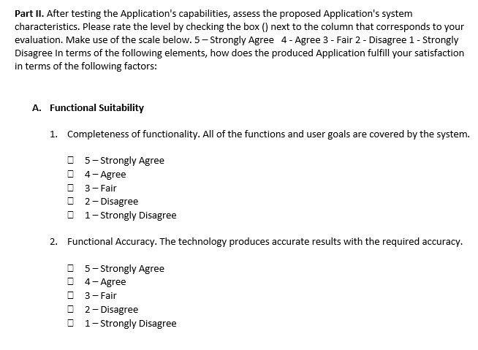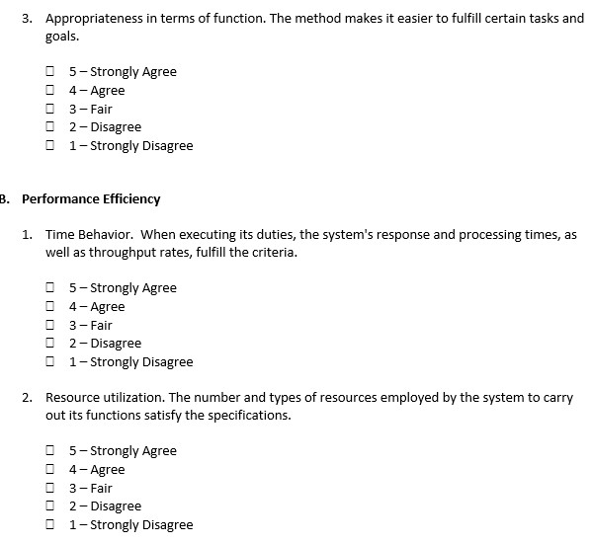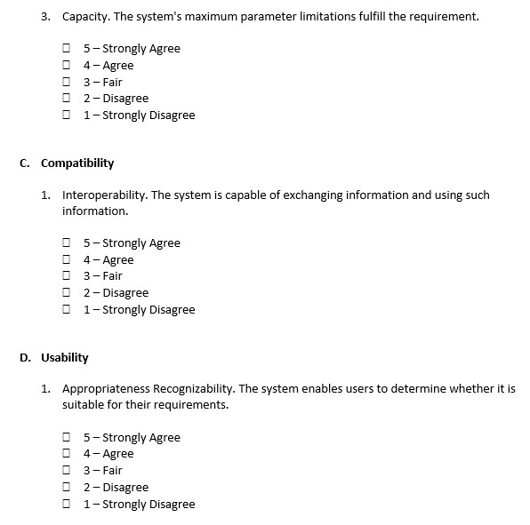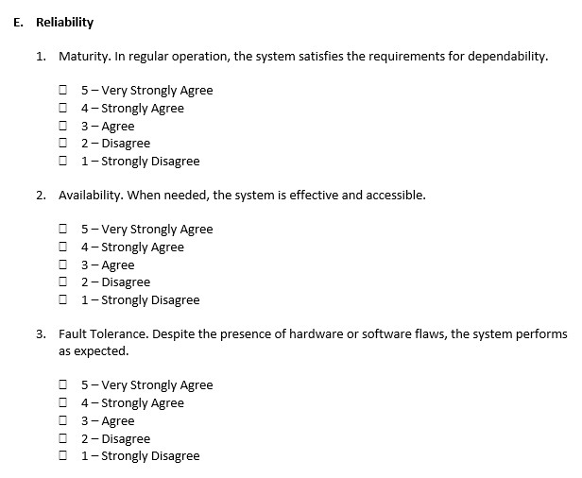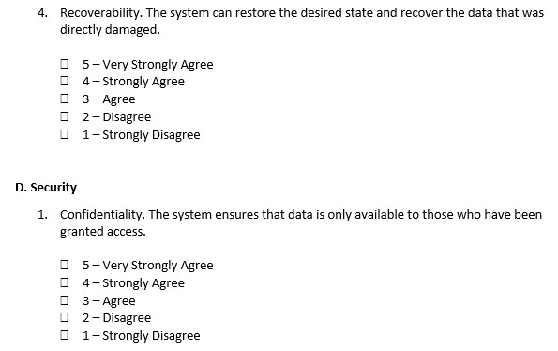

Figure 7: Post Survey (Proposed System) Questionnaire

# APPENDIX G

**(Letter of Request to Conduct a Study)**

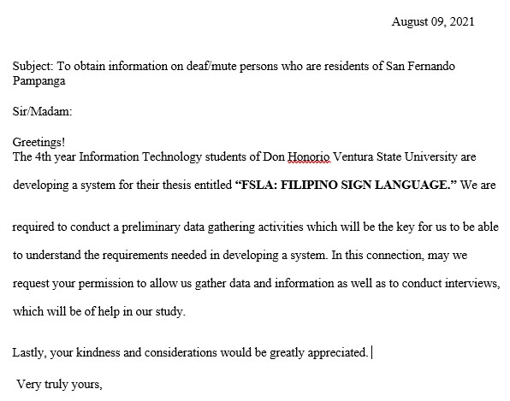

Figure 8: Letter of Request to Conduct a Study

# APPENDIX H

**(Academic Adviser Request**

**Letter**)

# APPENDIX I

## (Academic Adviser Request Letter)

Republic of the Philippines

### DON HONORIO VENTURA STATE UNIVERSITY

Villa de Bacolor, Pampanga

College of Computing Studies

*Date: January 5, 2021.*

Form_RES 003

#### RECOMMENDATION LETTER

This Thesis/Capstone entitled

found in order and hereby recommended for acceptance and approval for the FINAL

ORAL DEFENSE AND PRESENTATION.

SIGNATURE OVER PRINTED NAME

Academic/Technical Adviser

# APPENDIX J

## (System Codes)

**Main Activity (XML/JAVA)**

*<?***xml version="1.0" encoding="utf-8"***?>* <**androidx.constraintlayout.widget.ConstraintLayout xmlns:android="http://schemas.android.com/apk/res/android" xmlns:app="http://schemas.android.com/apk/res-auto" xmlns:tools="http://schemas.android.com/tools" android:layout_width="match_parent" android:layout_height="match_parent" android:backgroundTint="#FFFFFF"**   **tools:context=".MainActivity"**>

<**ImageView android:id="@+id/imageView" android:layout_width="495dp"**   **android:layout_height="897dp"**

**android:scaleType="fitXY"**

**app:layout_constraintBottom_toBottomOf="parent" app:layout_constraintEnd_toEndOf="parent" app:layout_constraintStart_toStartOf="parent" app:layout_constraintTop_toTopOf="parent" app:layout_constraintVertical_bias="0.0"**   **app:srcCompat="@drawable/bg"** />

<**ProgressBar android:id="@+id/progressBar"**

**style="?android:attr/progressBarStyle**

**"**

**android:layout_width="wrap_content**

**"**

**android:layout_height="wrap_content**

**"**   **android:visibility="invisible"**

**app:layout_constraintBottom_toBottomOf="parent" app:layout_constraintEnd_toEndOf="parent" app:layout_constraintHorizontal_bias="0.498" app:layout_constraintStart_toStartOf="parent" app:layout_constraintTop_toTopOf="parent"**   **app:layout_constraintVertical_bias="0.828"** />

<**Button android:id="@+id/button" android:layout_width="193dp" android:layout_height="60dp" android:backgroundTint="#AA**

**7051" android:text="GET**

**STARTED”**

**app:layout_constraintBottom_toTopOf="@+id/progressBar" app:layout_constraintEnd_toEndOf="parent" app:layout_constraintStart_toStartOf="parent" app:layout_constraintTop_toBottomOf="@+id/imageView3"**

**app:layout_constraintVertical_bias="1.0"** />

<**ImageView android:id="@+id/imageView3" android:layout_width="185dp" android:layout_height="165dp" android:layout_marginTop="236dp" app:layout_constraintEnd_toEndOf="parent" app:layout_constraintStart_toStartOf="parent" app:layout_constraintTop_toTopOf="parent"**   **app:srcCompat="@drawable/icon"** />

</**androidx.constraintlayout.widget.ConstraintLayout**>

Java **package** com.example.filipinosignlanguage;

**import** androidx.appcompat.app.AppCompatActivity;

**import** android.content.Intent; **import**

android.os.Bundle; **import** android.view.View; **import** android.widget.Button; **import** android.widget.ProgressBar;

**import** android.widget.Toast;

**public class** MainActivity **extends** AppCompatActivity {

Button **button**;

ProgressBar **progressBar**; **int counter**; @Override **public void** onBackPressed() {

finish();

**super**.onBackPressed();

}

@Override **protected void** onCreate(Bundle savedInstanceState) {

**super**.onCreate(savedInstanceState); setContentView(R.layout.***activity_main***); **progressBar** = findViewById(R.id.***progressBar***); **button** = findViewById(R.id.***button***);

**button**.setOnClickListener(**new** View.OnClickListener() {

@Override **public void** onClick(View v) {

startActivity(**new** Intent(getApplicationContext(), login.**class**));

}

});

}



}

### Nickname (XML/JAVA)

*<?***xml version="1.0" encoding="utf-8"***?>* <**androidx.constraintlayout.widget.ConstraintLayout xmlns:android="http://schemas.android.com/apk/res/android" xmlns:app="http://schemas.android.com/apk/res-auto" xmlns:tools="http://schemas.android.com/tools" android:layout_width="match_parent" android:layout_height="match_parent"**

**android:background="@drawable/bg"**   **tools:context=".login"**>

<**TextView**   **android:id="@+id/textView" android:layout_width="285dp" android:layout_height="40dp" android:layout_marginTop="236dp"**

**android:fontFamily="casual" android:text="Enter your Name" android:textAlignment="center" android:textColor="#FFFFFF" android:textSize="24sp" android:textStyle="bold"**

**app:layout_constraintEnd_toEndOf="parent" app:layout_constraintStart_toStartOf="parent" app:layout_constraintTop_toTopOf="parent"** />

<**EditText android:id="@+id/textBox"**

**android:layout_width="350dp" android:layout_height="46dp" android:layout_marginTop="72dp" android:hint="Enter Your Name" app:layout_constraintEnd_toEndOf="parent" app:layout_constraintHorizontal_bias="0.491" app:layout_constraintStart_toStartOf="parent"**   **app:layout_constraintTop_toBottomOf="@+id/textView"** />

<**Button android:id="@+id/passButton" android:layout_width="match_parent" android:layout_height="wrap_content" android:layout_marginTop="208dp"**

**android:text="Proceed"**

**app:layout_constraintEnd_toEndOf="parent" app:layout_constraintHorizontal_bias="0.0" app:layout_constraintStart_toStartOf="parent"**   **app:layout_constraintTop_toBottomOf="@+id/textBox"** />

</**androidx.constraintlayout.widget.ConstraintLayout**>

Java **package** com.example.filipinosignlanguage;

**import** androidx.annotation.NonNull; **import** androidx.annotation.Nullable; **import** androidx.appcompat.app.AlertDialog; **import** androidx.appcompat.app.AppCompatActivity;

**import** android.content.DialogInterface; **import** android.content.Intent; **import** android.os.Bundle; **import** android.text.TextUtils; **import** android.view.View; **import** android.view.animation.Animation; **import** android.view.animation.AnimationUtils; **import** android.widget.Button; **import** android.widget.EditText; **import** android.widget.TextView; **import** android.widget.Toast;

**import** com.google.android.gms.auth.api.Auth;

**import** com.google.android.gms.auth.api.signin.GoogleSignInOptions; **import** com.google.android.gms.auth.api.signin.GoogleSignInResult; **import** com.google.android.gms.common.ConnectionResult; **import** com.google.android.gms.common.SignInButton; **import** com.google.android.gms.common.api.GoogleApiClient; **import** com.google.android.gms.tasks.OnCompleteListener; **import** com.google.android.gms.tasks.Task; **import** com.google.firebase.auth.AuthResult;

**import** com.google.firebase.auth.FirebaseAuth;

@SuppressWarnings(**"deprecation"**) **public class** login **extends** AppCompatActivity {

@Override **public void** onBackPressed() {

finish();

**super**.onBackPressed(); startActivity(**new** Intent(getApplicationContext(), MainActivity.**class**));

}

EditText **textBox**;

Button **passButton**; @Override **protected void** onCreate(Bundle savedInstanceState) {

**super**.onCreate(savedInstanceState);

setContentView(R.layout.***activity_login***);

**textBox** = (EditText)findViewById(R.id.***textBox***);

**passButton** = (Button)findViewById(R.id.***passButton***);

**passButton**.setOnClickListener(**new** View.OnClickListener() { @Override **public void** onClick(View v) {

String str = **textBox**.getText().toString();

Intent intent = **new** Intent(getApplicationContext(), home.**class**); intent.putExtra(**"message"**, str);

startActivity(intent);

}

});

}

}

Fragment_Home (XML/JAVA)

*<?***xml version="1.0" encoding="utf-8"***?>*

<**LinearLayout xmlns:android="http://schemas.android.com/apk/res/android" xmlns:app="http://schemas.android.com/apk/res-auto" xmlns:tools="http://schemas.android.com/tools" android:layout_width="match_parent" android:layout_height="match_parent" tools:context=".ui.home.HomeFragment" android:orientation="vertical"**

**android:background="@drawable/bg"**

>

<**ScrollView**   **android:layout_width="match_parent"**   **android:layout_height="match_parent"**

>

<**LinearLayout**

**android:layout_width="match_parent"**

**android:layout_height="match_parent"**

**android:orientation="vertical"**>

<**TextView**   **android:id="@+id/text_home" android:layout_width="match_parent" android:layout_height="wrap_content" android:layout_marginStart="8dp" android:layout_marginTop="8dp" android:layout_marginEnd="8dp" android:textAlignment="center" android:textSize="20sp" android:visibility="invisible" android:fontFamily="casual"**

**app:layout_constraintBottom_toBottomOf="parent" app:layout_constraintEnd_toEndOf="parent"**

**app:layout_constraintStart_toStartOf="parent" app:layout_constraintTop_toTopOf="parent"**

/>

<**ImageButton android:id="@+id/imageButton" android:layout_width="match_parent" android:layout_height="wrap_content" android:backgroundTint="#00CABCBC" android:src="@drawable/wor" app:layout_constraintEnd_toEndOf="parent" app:layout_constraintStart_toStartOf="parent" app:layout_constraintTop_toTopOf="parent"** />

<**ImageButton android:id="@+id/imageButton2" android:layout_width="match_parent" android:layout_height="wrap_content" android:backgroundTint="#00FFFFFF" android:src="@drawable/dic2" app:layout_constraintEnd_toEndOf="parent" app:layout_constraintStart_toStartOf="parent"**

**app:layout_constraintTop_toBottomOf="@+id/imageButton"** />

<**ImageButton**   **android:id="@+id/imageButton3"**

**android:layout_width="match_parent" android:layout_height="wrap_content" android:backgroundTint="#00FFFFFF" android:src="@drawable/gam" app:layout_constraintEnd_toEndOf="parent" app:layout_constraintStart_toStartOf="parent"**   **app:layout_constraintTop_toBottomOf="@+id/imageButton2"** />

<**ImageButton android:id="@+id/imageButton4" android:layout_width="match_parent" android:layout_height="wrap_content" android:backgroundTint="#009A8181" android:src="@drawable/sto" app:layout_constraintEnd_toEndOf="parent" app:layout_constraintStart_toStartOf="parent"**

**app:layout_constraintTop_toBottomOf="@+id/imageButton3"** />

<**ImageButton android:id="@+id/imageButton5" android:layout_width="match_parent" android:layout_height="wrap_content" android:backgroundTint="#00FFFFFF" android:src="@drawable/fee" app:layout_constraintEnd_toEndOf="parent" app:layout_constraintStart_toStartOf="parent"**

**app:layout_constraintTop_toBottomOf="@+id/imageButton4"** />

</**LinearLayout**>

</**ScrollView**>

</**LinearLayout**>

Java **package** com.example.filipinosignlanguage.ui.home;

**import** android.content.Intent;

**import** android.os.Bundle; **import** android.view.LayoutInflater; **import** android.view.View; **import** android.view.ViewGroup; **import** android.widget.ImageButton;

**import** android.widget.TextView;

**import** androidx.annotation.NonNull; **import**

androidx.annotation.Nullable; **import** androidx.fragment.app.Fragment; **import** androidx.lifecycle.Observer; **import** androidx.lifecycle.ViewModelProvider; **import** com.example.filipinosignlanguage.R; **import** com.example.filipinosignlanguage.category; **import** com.example.filipinosignlanguage.dic; **import**

com.example.filipinosignlanguage.feedback; **import**

com.example.filipinosignlanguage.game; **import** com.example.filipinosignlanguage.stories;

**import** com.example.filipinosignlanguage.wordoftheday;

**public class** HomeFragment **extends** Fragment {

**private** HomeViewModel **homeViewModel**; **private** ImageButton **IB**,**IB2**,**IB3**,**IB4**,**IB5**;

**public** View onCreateView(@NonNull LayoutInflater inflater,

ViewGroup container, Bundle savedInstanceState) { **homeViewModel** = **new**

ViewModelProvider(**this**).get(HomeViewModel.**class**); View root = inflater.inflate(R.layout.***fragment_home***, container, **false**); **final** TextView textView = root.findViewById(R.id.***text_home***);

**IB**= root.findViewById(R.id. ***imageButton***);

**IB**.setOnClickListener(**new** View.OnClickListener() {

@Override **public void** onClick(View v) {

Intent intent = **new** Intent(getActivity(), wordoftheday.**class**); startActivity(intent);

}

});

**IB2**= root.findViewById(R.id. ***imageButton3***);

**IB2**.setOnClickListener(**new** View.OnClickListener() {

@Override **public void** onClick(View v) {

Intent intent = **new** Intent(getActivity(), game.**class**); startActivity(intent);

}

});

**IB3**= root.findViewById(R.id. ***imageButton2***);

**IB3**.setOnClickListener(**new** View.OnClickListener() {

@Override **public void** onClick(View v) { Intent intent = **new** Intent(getActivity(), category.**class**); startActivity(intent);

}

});

**IB4**= root.findViewById(R.id. ***imageButton5***);

**IB4**.setOnClickListener(**new** View.OnClickListener() {

@Override **public void** onClick(View v) {

Intent intent = **new** Intent(getActivity(), feedback.**class**); startActivity(intent);

}

});

**IB5**= root.findViewById(R.id. ***imageButton4***);

**IB5**.setOnClickListener(**new** View.OnClickListener() {

@Override **public void** onClick(View v) {

Intent intent = **new** Intent(getActivity(), stories.**class**); startActivity(intent);

}

});

**homeViewModel**.getText().observe(getViewLifecycleOwner(), **new** Observer<String>()

{

@Override **public void** onChanged(@Nullable String s) {

textView.setText(s);

}

}); **return** root;

}

}

**Word_Of_The Day (XML/JAVA)**

*<?***xml version="1.0" encoding="utf-8"***?>*  <**androidx.constraintlayout.widget.ConstraintLayout xmlns:android="http://schemas.android.com/apk/res/android" xmlns:app="http://schemas.android.com/apk/res-auto" xmlns:tools="http://schemas.android.com/tools" android:layout_width="match_parent" android:layout_height="match_parent" android:background="@drawable/bg"**   **tools:context=".wordoftheday"**>

<**FrameLayout android:id="@+id/frameLayout" android:layout_width="match_parent" android:layout_height="wrap_content" app:layout_constraintEnd_toEndOf="parent" app:layout_constraintStart_toStartOf="parent"**   **app:layout_constraintTop_toTopOf="parent"**>

<**VideoView android:id="@+id/video" android:layout_marginTop="80dp" android:layout_width="match_parent"**

**android:layout_height="488dp"**

**android:textAlignment="center"** />

</**FrameLayout**>

<**TextView android:id="@+id/textView18" android:layout_width="389dp" android:layout_height="129dp" android:layout_marginTop="40dp"**

**android:text="haha" android:textAlignment="center" android:textSize="24sp"**

**app:layout_constraintEnd_toEndOf="parent" app:layout_constraintStart_toStartOf="parent"**

**app:layout_constraintTop_toBottomOf="@+id/frameLayout"** />

</**androidx.constraintlayout.widget.ConstraintLayout**>

Java

**package** com.example.filipinosignlanguage;

**import** androidx.appcompat.app.AppCompatActivity;

**import** android.media.MediaPlayer;

**import** android.net.Uri; **import** android.os.Bundle; **import** android.widget.MediaController; **import** android.widget.TextView;

**import** android.widget.VideoView;

**import** java.util.Random;

**public class** wordoftheday **extends** AppCompatActivity {

Random **random** = **new** Random();

@Override **protected void** onCreate(Bundle savedInstanceState) {

**super**.onCreate(savedInstanceState);

setContentView(R.layout.***activity_wordoftheday***);

TextView mText;

**int** ranNum = **random**.nextInt((14+1)-1)+1; String rndom = **""**; **switch** (ranNum){

**case** 1 : {

VideoView videoView = findViewById(R.id.***video***);

String videopath = **"android.resource://"** + getPackageName() + **"/"** + R.raw.***when***;

Uri uri = Uri.*parse*(videopath); videoView.setVideoURI(uri); mText =

findViewById(R.id.***textView18***);

mText.setText(**"Kailan (When)"**);

videoView.start(); videoView.setOnPreparedListener(**new** MediaPlayer.OnPreparedListener() {

@Override **public void** onPrepared(MediaPlayer mp) {

mp.setLooping(**true**);

}

});

**break**;

}

**case** 2 : {

VideoView videoView = findViewById(R.id.***video***);

String videopath = **"android.resource://"** + getPackageName() + **"/"** + R.raw.***aso***; Uri uri = Uri.*parse*(videopath); videoView.setVideoURI(uri); mText = findViewById(R.id.***textView18***); mText.setText(**"Aso (Dog)"**); videoView.start();

videoView.setOnPreparedListener(**new** MediaPlayer.OnPreparedListener() {

@Override **public void** onPrepared(MediaPlayer mp) {

mp.setLooping(**true**);

}

});

**break**;

} **case** 3 : {

VideoView videoView = findViewById(R.id.***video***);

String videopath = **"android.resource://"** + getPackageName() + **"/"** + R.raw.***why***;

Uri uri = Uri.*parse*(videopath); videoView.setVideoURI(uri); mText =

findViewById(R.id.***textView18***); mText.setText(**"bakit (Why)"**);

videoView.start(); videoView.setOnPreparedListener(**new** MediaPlayer.OnPreparedListener() {

@Override **public void** onPrepared(MediaPlayer mp) {

mp.setLooping(**true**);

}

});

**break**;

} **case** 4 : {

VideoView videoView = findViewById(R.id.***video***);

String videopath = **"android.resource://"** + getPackageName() + **"/"** +

R.raw.***goodafternoon***;

Uri uri = Uri.*parse*(videopath); videoView.setVideoURI(uri); mText =

findViewById(R.id.***textView18***);

mText.setText(**"Magandang Hapon (Good Afternoon)"**);

videoView.start();

videoView.setOnPreparedListener(**new** MediaPlayer.OnPreparedListener() {

@Override **public void** onPrepared(MediaPlayer mp) { mp.setLooping(**true**);

}

});

**break**;

} **case** 5 : {

VideoView videoView = findViewById(R.id.***video***);

String videopath = **"android.resource://"** + getPackageName() + **"/"** + R.raw.***tiger***;

Uri uri = Uri.*parse*(videopath);

videoView.setVideoURI(uri); mText = findViewById(R.id.***textView18***);

mText.setText(**"Tigre (Tiger)"**);

videoView.start(); videoView.setOnPreparedListener(**new** MediaPlayer.OnPreparedListener() {

@Override **public void** onPrepared(MediaPlayer mp) {

mp.setLooping(**true**);

}

});

**break**;

} **case** 6 : {

VideoView videoView = findViewById(R.id.***video***);

String videopath = **"android.resource://"** + getPackageName() + **"/"** + R.raw.***tiger***;

Uri uri = Uri.*parse*(videopath); videoView.setVideoURI(uri); mText = findViewById(R.id.***textView18***);

mText.setText(**"Tigre (Tiger)"**);

videoView.start(); videoView.setOnPreparedListener(**new** MediaPlayer.OnPreparedListener() {

@Override **public void** onPrepared(MediaPlayer mp) {

mp.setLooping(**true**);

}

}); **break**;

}

**case** 7 : {

VideoView videoView = findViewById(R.id.***video***);

String videopath = **"android.resource://"** + getPackageName() + **"/"** +

R.raw.***goodevening***;

Uri uri = Uri.*parse*(videopath); videoView.setVideoURI(uri); mText = findViewById(R.id.***textView18***);

mText.setText(**"Magandang Gabi (Good Evening)"**); videoView.start();

videoView.setOnPreparedListener(**new** MediaPlayer.OnPreparedListener() {

@Override **public void** onPrepared(MediaPlayer mp) {

mp.setLooping(**true**);

}

});

**break**;

} **case** 8 : {

VideoView videoView = findViewById(R.id.***video***);

String videopath = **"android.resource://"** + getPackageName() + **"/"** +

R.raw.***goodmorning***;

Uri uri = Uri.*parse*(videopath); videoView.setVideoURI(uri); mText =

findViewById(R.id.***textView18***);

mText.setText(**"Magandang Umaga (Good Morning)"**);

videoView.start();

videoView.setOnPreparedListener(**new** MediaPlayer.OnPreparedListener() {

@Override **public void** onPrepared(MediaPlayer mp) {

mp.setLooping(**true**);

}

}); **break**;

}

**case** 9 : {

VideoView videoView = findViewById(R.id.***video***);

String videopath = **"android.resource://"** + getPackageName() + **"/"** + R.raw.***noon***;

Uri uri = Uri.*parse*(videopath); videoView.setVideoURI(uri); mText = findViewById(R.id.***textView18***); mText.setText(**"Tangali (noon)"**);

videoView.start(); videoView.setOnPreparedListener(**new** MediaPlayer.OnPreparedListener() {

@Override **public void** onPrepared(MediaPlayer mp) {

mp.setLooping(**true**);

}

});

**break**;

} **case** 10 : {

VideoView videoView = findViewById(R.id.***video***);

String videopath = **"android.resource://"** + getPackageName() + **"/"** + R.raw.***ant***;

Uri uri = Uri.*parse*(videopath); videoView.setVideoURI(uri); mText =

findViewById(R.id.***textView18***);

mText.setText(**"Langgam (Ant)"**);

videoView.start(); videoView.setOnPreparedListener(**new** MediaPlayer.OnPreparedListener() {

@Override **public void** onPrepared(MediaPlayer mp) {

mp.setLooping(**true**);

}

});

**break**;

} **case** 11 : {

VideoView videoView = findViewById(R.id.***video***);

String videopath = **"android.resource://"** + getPackageName() + **"/"** + R.raw.***bear***;

Uri uri = Uri.*parse*(videopath); videoView.setVideoURI(uri); mText = findViewById(R.id.***textView18***);

mText.setText(**"Oso (Bear)"**);

videoView.start(); videoView.setOnPreparedListener(**new** MediaPlayer.OnPreparedListener() {

@Override **public void** onPrepared(MediaPlayer mp) { mp.setLooping(**true**);

}

});

**break**;

} **case** 12 : {

VideoView videoView = findViewById(R.id.***video***);

String videopath = **"android.resource://"** + getPackageName() + **"/"** + R.raw.***bird***;

Uri uri = Uri.*parse*(videopath); videoView.setVideoURI(uri); mText = findViewById(R.id.***textView18***); mText.setText(**"Ibon (Bird)"**);

videoView.start(); videoView.setOnPreparedListener(**new** MediaPlayer.OnPreparedListener() {

@Override **public void** onPrepared(MediaPlayer mp) {

mp.setLooping(**true**);

}

});

**break**;

} **case** 13 : {

VideoView videoView = findViewById(R.id.***video***);

String videopath = **"android.resource://"** + getPackageName() + **"/"** + R.raw.***pusa***;

Uri uri = Uri.*parse*(videopath); videoView.setVideoURI(uri); mText = findViewById(R.id.***textView18***);

mText.setText(**"Pusa (Cat)"**);

videoView.start(); videoView.setOnPreparedListener(**new** MediaPlayer.OnPreparedListener() {

@Override **public void** onPrepared(MediaPlayer mp) {

mp.setLooping(**true**);

}

});

**break**;

} **case** 14 : {

VideoView videoView = findViewById(R.id.***video***);

String videopath = **"android.resource://"** + getPackageName() + **"/"** +

R.raw.***where***;

Uri uri = Uri.*parse*(videopath); videoView.setVideoURI(uri); mText =

findViewById(R.id.***textView18***); mText.setText(**"Saan (where)"**); videoView.start(); videoView.setOnPreparedListener(**new** MediaPlayer.OnPreparedListener() {

@Override **public void** onPrepared(MediaPlayer mp) {

mp.setLooping(**true**);

}

});

**break**;

} **case** 15 : {

VideoView videoView = findViewById(R.id.***video***);

String videopath = **"android.resource://"** + getPackageName() + **"/"** + R.raw.***what***;

Uri uri = Uri.*parse*(videopath); videoView.setVideoURI(uri); mText =

findViewById(R.id.***textView18***); mText.setText(**"Ano (What)"**);

videoView.start(); videoView.setOnPreparedListener(**new** MediaPlayer.OnPreparedListener() {

@Override **public void** onPrepared(MediaPlayer mp) {

mp.setLooping(**true**);

}

});

**break**;

} **case** 16 : {

VideoView videoView = findViewById(R.id.***video***);

String videopath = **"android.resource://"** + getPackageName() + **"/"** + R.raw.***who***;

Uri uri = Uri.*parse*(videopath); videoView.setVideoURI(uri); mText = findViewById(R.id.***textView18***); mText.setText(**"Sino? (who)"**);

videoView.start(); videoView.setOnPreparedListener(**new** MediaPlayer.OnPreparedListener()

{

@Override **public void** onPrepared(MediaPlayer mp) {

mp.setLooping(**true**);

}

});

**break**;

}

}

}}

**Category (XML/JAVA)**

*<?***xml version="1.0" encoding="utf-8"***?>* <**androidx.constraintlayout.widget.ConstraintLayout xmlns:android="http://schemas.android.com/apk/res/android" xmlns:app="http://schemas.android.com/apk/res-auto" xmlns:tools="http://schemas.android.com/tools" android:layout_width="match_parent" android:layout_height="match_parent"**

**android:background="@drawable/bg"**   **tools:context=".category"**>

<**TextView**   **android:id="@+id/text_home" android:layout_width="match_parent" android:layout_height="wrap_content" android:layout_marginStart="8dp" android:layout_marginTop="8dp" android:layout_marginEnd="8dp" android:textAlignment="center" android:textSize="20sp" android:visibility="invisible" android:fontFamily="casual"**

**app:layout_constraintBottom_toBottomOf="parent" app:layout_constraintEnd_toEndOf="parent" app:layout_constraintStart_toStartOf="parent"**

**app:layout_constraintTop_toTopOf="parent"**

/>

<**ScrollView**

**android:layout_width="match_parent"**

**android:layout_height="match_parent"**

>

<**LinearLayout android:layout_width="match_parent" android:layout_height="match_parent"**  **android:layout_marginLeft="40dp"**

**android:orientation="vertical"**> <**Button android:id="@+id/button2" android:layout_width="317dp" android:layout_height="72dp" android:layout_marginTop="24dp" android:text="Letra (Alphabet)" android:textSize="18sp"**

**app:layout_constraintEnd_toEndOf="parent" app:layout_constraintStart_toStartOf="parent"**

**app:layout_constraintTop_toTopOf="parent"** />

<**Button android:id="@+id/button6" android:layout_width="317dp" android:layout_height="72dp" android:layout_marginTop="8dp" android:text="Numero (Numbers)" android:textSize="18sp"**

**app:layout_constraintEnd_toEndOf="parent" app:layout_constraintStart_toStartOf="parent"**

**app:layout_constraintTop_toBottomOf="@+id/button2"** />

<**Button android:id="@+id/button9" android:layout_width="317dp" android:layout_height="72dp" android:layout_marginTop="4dp" android:text="Emosyon (Emotion)" android:textSize="18sp" app:layout_constraintEnd_toEndOf="p**

**arent"**

**app:layout_constraintStart_toStartOf=**

**"parent"**   **app:layout_constraintTop_toBottomOf="@+id/button6"** />

<**Button android:id="@+id/button10" android:layout_width="317dp" android:layout_height="72dp" android:layout_marginTop="4dp" android:text="Hayop (Animals)" android:textSize="18sp"**

**app:layout_constraintEnd_toEndOf="parent" app:layout_constraintStart_toStartOf="parent"**   **app:layout_constraintTop_toBottomOf="@+id/button9"** />

<**Button android:id="@+id/button11" android:layout_width="317dp" android:layout_height="72dp"**

**android:layout_marginTop="4dp" android:text="pagbati**

**(Greetings)" android:textSize="18sp" app:layout_constraintEnd_toEndOf="parent" app:layout_constraintStart_toStartOf="parent" app:layout_constraintTop_toBottomOf="@+id/button10"** />

<**Button android:id="@+id/button12" android:layout_width="317dp" android:layout_height="72dp"**

**android:layout_marginTop="4dp" android:text="Panahon**

**(weather)" android:textSize="18sp" app:layout_constraintEnd_toEndOf="parent" app:layout_constraintStart_toStartOf="parent" app:layout_constraintTop_toBottomOf="@+id/button11"** />

<**Button**

**android:id="@+id/button13" android:layout_width="317dp" android:layout_height="72dp" android:layout_marginTop="8dp" android:text="Buwan (month)"**

**android:textSize="18sp"**

**app:layout_constraintEnd_toEndOf="p**

**arent"**

**app:layout_constraintStart_toStartOf="**

**parent"**

**app:layout_constraintTop_toBottomOf=**

**"@+id/button12"** />

<**Button android:id="@+id/button14" android:layout_width="317dp" android:layout_height="72dp"**

**android:layout_marginTop="8dp" android:text="prutas**

**(fruits)" android:textSize="18sp" app:layout_constraintEnd_toEndOf="parent" app:layout_constraintStart_toStartOf="parent" app:layout_constraintTop_toBottomOf="@+id/button13"** />

<**Button android:id="@+id/button15" android:layout_width="317dp" android:layout_height="72dp"**

**android:layout_marginTop="8dp" android:text="Gulay (Vegetables)" android:textSize="18sp" app:layout_constraintEnd_toEndOf="parent" app:layout_constraintStart_toStartOf="parent" app:layout_constraintTop_toBottomOf="@+id/button14"** />

<**Button android:id="@+id/button16"**

**android:layout_width="317dp" android:layout_height="72dp"**

**android:layout_marginTop="8dp" android:text="W Questions" android:textSize="18sp" app:layout_constraintEnd_toEndOf="parent" app:layout_constraintStart_toStartOf="parent" app:layout_constraintTop_toBottomOf="@+id/button14"** />

<**Button**   **android:id="@+id/button17" android:layout_width="317dp" android:layout_height="72dp" android:layout_marginTop="8dp" android:text="Araw (Days)" android:textSize="18sp"**   **app:layout_constraintEnd_toEndOf="parent"**

**app:layout_constraintStart_toStartOf="parent" app:layout_constraintTop_toBottomOf="@+id/button14"** />

</**LinearLayout**>

</**ScrollView**>

</**androidx.constraintlayout.widget.ConstraintLayout**>

Java **package** com.example.filipinosignlanguage;

**import** androidx.appcompat.app.AppCompatActivity;

**import** android.content.Intent; **import** android.os.Bundle; **import** android.view.View; **import** android.widget.Button; **import** android.widget.ImageButton; **import** android.widget.ImageView;

**public class** category **extends** AppCompatActivity {

Button **img1**,**img2**,**img3**,**img4**,**img5**,**img6**,**img7**,**img8**,**img9**,**img10**,**img11**;

@Override **public void** onBackPressed() {

finish();

startActivity(**new** Intent(getApplicationContext(),home.**class**));

}

@Override **protected void** onCreate(Bundle savedInstanceState) {

**super**.onCreate(savedInstanceState);

setContentView(R.layout.***activity_category***);

**img1** = findViewById(R.id.***button2***);

**img2** = findViewById(R.id.***button6***); **img3** = findViewById(R.id.***button9***); **img4** = findViewById(R.id.***button10***); **img5** = findViewById(R.id.***button11***); **img6** = findViewById(R.id.***button12***); **img7** = findViewById(R.id.***button13***); **img8** = findViewById(R.id.***button14***); **img9** = findViewById(R.id.***button15***); **img10** = findViewById(R.id.***button16***); **img11** = findViewById(R.id.***button17***);

**img1**.setOnClickListener(**new** View.OnClickListener() {

@Override **public void** onClick(View v) {

startActivity(**new** Intent(getApplicationContext(), dic.**class**));

}

});

**img5**.setOnClickListener(**new** View.OnClickListener() {

@Override **public void** onClick(View v) {

startActivity(**new** Intent(getApplicationContext(),

greetings.**class**));

}

});

**img2**.setOnClickListener(**new** View.OnClickListener() {

@Override **public void** onClick(View v) {

startActivity(**new** Intent(getApplicationContext(), num.**class**));

}

});

**img3**.setOnClickListener(**new** View.OnClickListener() {

@Override **public void** onClick(View v) { startActivity(**new** Intent(getApplicationContext(), emotion.**class**));

}

});

**img4**.setOnClickListener(**new** View.OnClickListener() {

@Override **public void** onClick(View v) {

startActivity(**new** Intent(getApplicationContext(), animals.**class**));

}

});

**img6**.setOnClickListener(**new** View.OnClickListener() {

@Override **public void** onClick(View v) {

startActivity(**new** Intent(getApplicationContext(), weather.**class**));

}

});

**img7**.setOnClickListener(**new** View.OnClickListener() {

@Override **public void** onClick(View v) {

startActivity(**new** Intent(getApplicationContext(), month.**class**));

}

});

**img8**.setOnClickListener(**new** View.OnClickListener() {

@Override **public void** onClick(View v) {

startActivity(**new** Intent(getApplicationContext(), fruitsandvegies.**class**));

}

});

**img9**.setOnClickListener(**new** View.OnClickListener() {

@Override **public void** onClick(View v) {

startActivity(**new** Intent(getApplicationContext(), vehicle.**class**));

}

});

**img10**.setOnClickListener(**new** View.OnClickListener() {

@Override **public void** onClick(View v) {

startActivity(**new** Intent(getApplicationContext(), que.**class**));



}

});

**img11**.setOnClickListener(**new** View.OnClickListener() {

@Override **public void** onClick(View v) {

startActivity(**new** Intent(getApplicationContext(), day.**class**));

}

});

}

}

**Letra (XML/JAVA)**

*<?***xml version="1.0" encoding="utf-8"***?>*

<**LinearLayout xmlns:android="http://schemas.android.com/apk/res/android" xmlns:app="http://schemas.android.com/apk/res-auto" xmlns:tools="http://schemas.android.com/tools"**

**android:layout_width="match_parent" android:orientation="vertical" android:layout_height="match_parent"**

**android:background="@drawable/bg"**   **tools:context=".dic"**>

<**ListView**   **android:id="@+id/listview"**

**android:layout_width="match_parent"**

**android:layout_height="wrap_content"**/>

</**LinearLayout**>

Java



**package** com.example.filipinosignlanguage;

**import** androidx.appcompat.app.AppCompatActivity;

**import** androidx.annotation.NonNull;

**import** androidx.appcompat.app.ActionBar;

**import** androidx.appcompat.app.AppCompatActivity;

**import** android.content.Context; **import** android.content.Intent; **import** android.os.Bundle; **import** android.util.Log; **import** android.view.Menu; **import** android.view.MenuInflater; **import** android.view.MenuItem; **import** android.view.View; **import** android.view.ViewGroup; **import** android.widget.AdapterView; **import** android.widget.BaseAdapter; **import** android.widget.Filter; **import** android.widget.Filterable; **import** android.widget.ImageView; **import** android.widget.ListView; **import** android.widget.SearchView;

**import** android.widget.TextView;

**import** java.util.ArrayList;

**import** java.util.List;

**public class** dic **extends** AppCompatActivity {

String **names**[] =

{**"A"**,**"B"**,**"C"**,**"D"**,**"E"**,**"F"**,**"G"**,**"H"**,**"I"**,**"J"**,**"K"**,**"L"**,**"M"**,**"N"**,**"O"**,**"P"**,**"Q"**,**"R"**,**"S**

**"**,**"T"**,**"U"**,**"V"**,**"W"**,**"X"**,**"Y"**,**"Z"**};

String **emails**[] = {**"A is for apple"**,**"B is for boy"**,**"C is for cat"**,**"D is for dog"**,**"E is for egg"**,**"F is for fox"**,**"G is for goat"**,**"H is for hotdog"**,**"I is for ice"**,**"J is for juice"**,**"K is for key"**,**"L is for love"**,**"M is for mouse"**,**"N is for nose"**,**"O is for orange"**,**"P is for plate"**,**"Q is for queen"**,**"R is for royal"**,**"S is for snake"**,**"T is for table"**,**"U is for umbrella"**,**"V is for violin"**,**"W is for watch"**,**"X is xerox!"**,**"Y is for yakult"**,**"Z is for zombie"**};

**int images**[] = {R.drawable.***test3***, R.drawable.***b***, R.drawable.***c***, R.drawable.***d***, R.drawable.***e***,

R.drawable.***f***, R.drawable.***g***, R.drawable.***h***, R.drawable.***i***, R.drawable.***j***, R.drawable.***k***,

R.drawable.***l***, R.drawable.***m***, R.drawable.***n***, R.drawable.***o***, R.drawable.***p***, R.drawable.***q***,



R.drawable.***r***, R.drawable.***s***, R.drawable.***t***, R.drawable.***u***, R.drawable.***v***,

R.drawable.***w***,R.drawable.***x***, R.drawable.***y***,R.drawable.***z***};

List<ItemsModel> **itemsModelList** = **new** ArrayList<>();

ListView **listView**;

CustomAdapter **customAdapter**;

@Override **public void** onBackPressed() {

finish();

startActivity(**new** Intent(getApplicationContext(),category.**class**));

}

@Override **protected void** onCreate(Bundle savedInstanceState) {

**super**.onCreate(savedInstanceState);

setContentView(R.layout.***activity_dic***);

**listView** = findViewById(R.id.***listview***);

**for**(**int** i = 0;i < **names**.**length**;i++){

ItemsModel itemsModel = **new** ItemsModel(**names**[i],**emails**[i],**images**[i]);

**itemsModelList**.add(itemsModel);

}

**customAdapter** = **new** CustomAdapter(**itemsModelList**,**this**);

**listView**.setAdapter(**customAdapter**);

}

@Override **public boolean** onCreateOptionsMenu(Menu menu) {

getMenuInflater().inflate(R.menu.***search_menu***,menu);

MenuItem menuItem = menu.findItem(R.id.***searchView***);

SearchView searchView = (SearchView) menuItem.getActionView();

searchView.setOnQueryTextListener(**new** SearchView.OnQueryTextListener() {

@Override **public boolean** onQueryTextSubmit(String query) {

**return false**;

}

@Override **public boolean** onQueryTextChange(String newText) { Log.*e*(**"Main"**,**" data search"**+newText);

**customAdapter**.getFilter().filter(newText);

**return true**;

}

});

**return true**;

}

@Override **public boolean** onOptionsItemSelected(@NonNull MenuItem item) {

**int** id = item.getItemId();

**if**(id == R.id.***searchView***){

**return true**;

}

**return super**.onOptionsItemSelected(item);

}

**public class** CustomAdapter **extends** BaseAdapter **implements** Filterable {

**private** List<ItemsModel> **itemsModelsl**;

**private** List<ItemsModel> **itemsModelListFiltered**;

**private** Context **context**;

**public** CustomAdapter(List<ItemsModel> itemsModelsl, Context context) {

**this**.**itemsModelsl** = itemsModelsl; **this**.**itemsModelListFiltered** = itemsModelsl;

**this**.**context** = context;

}

@Override **public int** getCount() {

**return itemsModelListFiltered**.size();

}

@Override **public** Object getItem(**int** position) {

**return itemsModelListFiltered**.get(position);

}

@Override **public long** getItemId(**int** position) {

**return** position;

}

@Override **public** View getView(**final int** position, View convertView, ViewGroup parent) { View view = getLayoutInflater().inflate(R.layout.***row_items***,**null**);

TextView names = view.findViewById(R.id.***name***);

TextView emails = view.findViewById(R.id.***email***);

ImageView imageView = view.findViewById(R.id.***images***);

names.setText(**itemsModelListFiltered**.get(position).getName());

emails.setText(**itemsModelListFiltered**.get(position).getEmail());

imageView.setImageResource(**itemsModelListFiltered**.get(position).getImages());

view.setOnClickListener(**new** View.OnClickListener() {

@Override **public void** onClick(View v) {

Log.*e*(**"main activity"**,**"item clicked"**);

startActivity(**new**

Intent(dic.**this**,ItemsPreview.**class**).putExtra(**"items"**,**itemsModelListFiltered**.get(position)))

;

}

});

**return** view;

}

@Override **public** Filter getFilter() {

Filter filter = **new** Filter() {

@Override **protected** FilterResults performFiltering(CharSequence constraint) {

FilterResults filterResults = **new** FilterResults(); **if**(constraint == **null** || constraint.length() == 0){ filterResults.**count** = **itemsModelsl**.size();

filterResults.**values** = **itemsModelsl**;

}**else**{

List<ItemsModel> resultsModel = **new** ArrayList<>();

String searchStr = constraint.toString().toLowerCase();

**for**(ItemsModel itemsModel:**itemsModelsl**){ **if**(itemsModel.getName().contains(searchStr) ||

itemsModel.getEmail().contains(searchStr)){

resultsModel.add(itemsModel);

} filterResults.**count** = resultsModel.size();

filterResults.**values** = resultsModel;

}

}

**return** filterResults;

}

@Override **protected void** publishResults(CharSequence constraint, FilterResults results) {

**itemsModelListFiltered** = (List<ItemsModel>) results.**values**;

notifyDataSetChanged();

}

}; **return** filter;

}

}

}

**Numero (XML/JAVA)**

*<?***xml version="1.0" encoding="utf-8"***?>*

<**LinearLayout xmlns:android="http://schemas.android.com/apk/res/android" xmlns:app="http://schemas.android.com/apk/res-auto" xmlns:tools="http://schemas.android.com/tools" android:layout_width="match_parent" android:layout_height="match_parent" tools:context=".ui.home.HomeFragment" android:orientation="vertical"**

**android:background="@drawable/bg"**

>

<**ScrollView**

**android:layout_width="match_parent"**

**android:layout_height="match_parent"**

>

<**LinearLayout**

**android:layout_width="match_parent"**

**android:layout_height="match_parent"**

**android:orientation="vertical"**>

<**TextView**   **android:id="@+id/text_home" android:layout_width="match_parent" android:layout_height="wrap_content" android:layout_marginStart="8dp" android:layout_marginTop="8dp" android:layout_marginEnd="8dp" android:textAlignment="center" android:textSize="20sp" android:visibility="invisible" android:fontFamily="casual"**

**app:layout_constraintBottom_toBottomOf="parent"**

**app:layout_constraintEnd_toEndOf="parent"**

**app:layout_constraintStart_toStartOf="parent" app:layout_constraintTop_toTopOf="parent"**

/>

<**ImageView android:id="@+id/one" android:layout_width="match_parent" android:layout_height="206dp"**   **app:srcCompat="@drawable/one"** />

<**ImageView android:id="@+id/two" android:layout_width="match_parent"**

**android:layout_height="206dp"**

**app:srcCompat="@drawable/two"** />

<**ImageView android:id="@+id/three" android:layout_width="match_parent" android:layout_height="206dp"**

**app:srcCompat="@drawable/three"** />

<**ImageView android:id="@+id/four" android:layout_width="match_parent" android:layout_height="206dp"**

**app:srcCompat="@drawable/four"** />

<**ImageView android:id="@+id/five" android:layout_width="match_parent" android:layout_height="206dp"**

**app:srcCompat="@drawable/five"** />

<**ImageView android:id="@+id/six" android:layout_width="match_parent"**

**android:layout_height="206dp"**

**app:srcCompat="@drawable/six"** />

<**ImageView android:id="@+id/seven" android:layout_width="match_parent" android:layout_height="206dp"**

**app:srcCompat="@drawable/seven"** />

<**ImageView android:id="@+id/eight" android:layout_width="match_parent" android:layout_height="206dp"**

**app:srcCompat="@drawable/eight"** />

<**ImageView android:id="@+id/nine"**  **android:layout_width="match_parent" android:layout_height="206dp"**

**app:srcCompat="@drawable/nine"** />

<**ImageView android:id="@+id/ten" android:layout_width="match_parent"**

**android:layout_height="206dp"**

**app:srcCompat="@drawable/ten"** />

</**LinearLayout**>

</**ScrollView**>

</**LinearLayout**>

Java **package** com.example.filipinosignlanguage;

**import** androidx.annotation.NonNull; **import** androidx.appcompat.app.AppCompatActivity;

**import** android.content.Context; **import** android.content.Intent; **import** android.os.Bundle; **import** android.util.Log; **import** android.view.Menu; **import** android.view.MenuItem; **import** android.view.View; **import** android.view.ViewGroup; **import** android.widget.BaseAdapter; **import** android.widget.Filter; **import** android.widget.Filterable; **import** android.widget.ImageView; **import** android.widget.ListView; **import** android.widget.SearchView; **import** android.widget.TextView;

**import** java.util.ArrayList; **import** java.util.List;

**public class** num **extends** AppCompatActivity {

@Override **public void** onBackPressed() { finish(); startActivity(**new** Intent(getApplicationContext(), category.**class**));

}

@Override **protected void** onCreate(Bundle savedInstanceState) { **super**.onCreate(savedInstanceState);

setContentView(R.layout.***activity_num***);

}

}

**Emosyon (XML/JAVA)**

*<?***xml version="1.0" encoding="utf-8"***?>*

<**LinearLayout**

**xmlns:android="http://schemas.android.com/apk/res/android" xmlns:app="http://schemas.android.com/apk/res-auto" xmlns:tools="http://schemas.android.com/tools" android:layout_width="match_parent" android:layout_height="match_parent"**

**tools:context=".emotion" android:orientation="vertical"**   **android:background="@drawable/bg"**

>

<**ScrollView**   **android:layout_width="match_parent"**   **android:layout_height="match_parent"**

>

<**LinearLayout**

**android:layout_width="match_parent"**   **android:layout_height="match_parent"**

**android:orientation="vertical"**>

<**TextView**

**android:id="@+id/text_home" android:layout_width="match_parent"**

**android:layout_height="wrap_content"**

**android:layout_marginStart="8dp" android:layout_marginTop="8dp" android:layout_marginEnd="8dp" android:textAlignment="center" android:textSize="20sp" android:visibility="invisible" android:fontFamily="casual"**

**app:layout_constraintBottom_toBottomOf="parent" app:layout_constraintEnd_toEndOf="parent" app:layout_constraintStart_toStartOf="parent"**   **app:layout_constraintTop_toTopOf="parent"**

/>

<**Button**   **android:id="@+id/btn1" android:layout_marginTop="100dp" android:layout_marginLeft="30dp" android:layout_width="302dp"**

**android:layout_height="wrap_content"**

**android:text="Angry (Galit)"** />

<**Button**   **android:id="@+id/btn2" android:layout_marginTop="40dp" android:layout_marginLeft="30dp" android:layout_width="302dp"**

**android:layout_height="wrap_content"**

**android:text="Naiinip (Bored)"** />

<**Button**   **android:id="@+id/btn3" android:layout_marginTop="40dp" android:layout_marginLeft="30dp" android:layout_width="302dp"**

**android:layout_height="wrap_content"**   **android:text="Nasasabik (Excited)"** />

<**Button**   **android:id="@+id/btn4" android:layout_marginTop="40dp" android:layout_marginLeft="30dp"**  **android:layout_width="302dp" android:layout_height="wrap_content"**  **android:text="Mabigo (Disappoint)"** />

<**Button**

**android:id="@+id/btn5" android:layout_marginTop="40dp" android:layout_marginLeft="30dp" android:layout_width="302dp" android:layout_height="wrap_content"**   **android:text="Masaya (Happy)"** />

<**Button**

**android:id="@+id/btn6" android:layout_marginTop="40dp" android:layout_marginLeft="30dp" android:layout_width="302dp"**

**android:layout_height="wrap_content"**

**android:text="Pag-Ibig (Love)"** />

<**Button**

**android:id="@+id/btn7" android:layout_marginTop="40dp" android:layout_marginLeft="30dp" android:layout_width="302dp" android:layout_height="wrap_content"**   **android:text="Magpahinga (Relax)"** />

<**Button**

**android:id="@+id/btn8" android:layout_marginTop="40dp" android:layout_marginLeft="30dp" android:layout_width="302dp" android:layout_height="wrap_content"**   **android:text="Malungkot (Sad)"** />

<**Button**

**android:id="@+id/btn9" android:layout_marginTop="40dp" android:layout_marginLeft="30dp" android:layout_width="302dp"**

**android:layout_height="wrap_content"**

**android:text="Nasiyahan (Satisfied)"** />

<**Button**

**android:id="@+id/btn10" android:layout_marginTop="40dp" android:layout_marginLeft="30dp"**   **android:layout_width="302dp" android:layout_height="wrap_content"**

**android:text="Seryoso (Serious)"** />

<**Button**

**android:id="@+id/btn11" android:layout_marginTop="40dp" android:layout_marginLeft="30dp" android:layout_width="302dp"**

**android:layout_height="wrap_content"**

**android:text="Nahihiya (Shy)"** />

<**Button**

**android:id="@+id/btn12" android:layout_marginTop="40dp" android:layout_marginLeft="30dp" android:layout_width="302dp"**

**android:layout_height="wrap_content"**

**android:text="Nagulat (Surprised)"** />

<**Button**

**android:id="@+id/btn13" android:layout_marginTop="40dp" android:layout_marginLeft="30dp" android:layout_width="302dp" android:layout_height="wrap_content"**

**android:text="Pagod (Tired)"** />

</**LinearLayout**>

</**ScrollView**>

</**LinearLayout**>

Java

**package** com.example.filipinosignlanguage;

**import** androidx.appcompat.app.AppCompatActivity;

**import** android.content.Intent; **import** android.os.Bundle; **import** android.view.View;

**import** android.widget.Button;

**public class** emotion **extends** AppCompatActivity {

Button **btn1**,**btn2**,**btn3**,**btn4**,**btn5**,**btn6**,**btn7**,**btn8**,**btn9**,**btn10**,**btn11**,**btn12**,**btn13**;

@Override **public void** onBackPressed() {

finish();

startActivity(**new** Intent(getApplicationContext(),category.**class**));

}

@Override **protected void** onCreate(Bundle savedInstanceState) {

**super**.onCreate(savedInstanceState);

setContentView(R.layout.***activity_emotion***);

**btn1** = findViewById(R.id.***btn1***);

**btn2** = findViewById(R.id.***btn2***); **btn3** = findViewById(R.id.***btn3***); **btn4** = findViewById(R.id.***btn4***); **btn5** = findViewById(R.id.***btn5***); **btn6** = findViewById(R.id.***btn6***); **btn7** = findViewById(R.id.***btn7***); **btn8** = findViewById(R.id.***btn8***); **btn9** = findViewById(R.id.***btn9***); **btn10** = findViewById(R.id.***btn10***); **btn11** = findViewById(R.id.***btn11***); **btn12** = findViewById(R.id.***btn12***); **btn13** = findViewById(R.id.***btn13***);

**btn1**.setOnClickListener(**new** View.OnClickListener() {

@Override **public void** onClick(View v) { startActivity(**new** Intent(getApplicationContext(), bad.**class**));

}

});

**btn2**.setOnClickListener(**new** View.OnClickListener() {

@Override **public void** onClick(View v) {

startActivity(**new** Intent(getApplicationContext(), good.**class**));

}

});

**btn3**.setOnClickListener(**new** View.OnClickListener() {

@Override **public void** onClick(View v) {

startActivity(**new** Intent(getApplicationContext(), emba.**class**));

}

});

**btn4**.setOnClickListener(**new** View.OnClickListener() {

@Override **public void** onClick(View v) {

startActivity(**new** Intent(getApplicationContext(), excited.**class**));

}

});

**btn5**.setOnClickListener(**new** View.OnClickListener() {

@Override **public void** onClick(View v) { startActivity(**new** Intent(getApplicationContext(), shy.**class**));

}

});

**btn6**.setOnClickListener(**new** View.OnClickListener() {

@Override **public void** onClick(View v) {

startActivity(**new** Intent(getApplicationContext(), love.**class**));

}

});

**btn7**.setOnClickListener(**new** View.OnClickListener() {

@Override **public void** onClick(View v) {

startActivity(**new** Intent(getApplicationContext(), relax.**class**));

}

});

**btn8**.setOnClickListener(**new** View.OnClickListener() {

@Override **public void** onClick(View v) {

startActivity(**new** Intent(getApplicationContext(), sad.**class**));

}

});

**btn9**.setOnClickListener(**new** View.OnClickListener() {

@Override **public void** onClick(View v) { startActivity(**new** Intent(getApplicationContext(), satisfied.**class**));

}

});

**btn10**.setOnClickListener(**new** View.OnClickListener() {

@Override **public void** onClick(View v) {

startActivity(**new** Intent(getApplicationContext(), serious.**class**));

}

});

**btn11**.setOnClickListener(**new** View.OnClickListener() {

@Override **public void** onClick(View v) {

startActivity(**new** Intent(getApplicationContext(), shyy.**class**));

}

});

**btn12**.setOnClickListener(**new** View.OnClickListener() {

@Override **public void** onClick(View v) {

startActivity(**new** Intent(getApplicationContext(),

surprised.**class**));

}

});

**btn13**.setOnClickListener(**new** View.OnClickListener() {

@Override **public void** onClick(View v) {

startActivity(**new** Intent(getApplicationContext(), tired.**class**));

}

});

}

}

**Hayop (XML/JAVA)**

*<?***xml version="1.0" encoding="utf-8"***?>*

<**LinearLayout**

**xmlns:android="http://schemas.android.com/apk/res/android" xmlns:app="http://schemas.android.com/apk/res-auto" xmlns:tools="http://schemas.android.com/tools" android:layout_width="match_parent" android:layout_height="match_parent"**

**tools:context=".animals" android:orientation="vertical"**   **android:background="@drawable/bg"**

>

<**ScrollView**

**android:layout_width="match_parent"**   **android:layout_height="match_parent"**

>

<**LinearLayout**

**android:layout_width="match_parent"**

**android:layout_height="match_parent"**

**android:orientation="vertical"**>

<**Button**

**android:id="@+id/btn1"**   **android:layout_width="302dp" android:layout_height="wrap_content"**

**android:layout_marginLeft="30dp"**

**android:layout_marginTop="100dp"**

**android:text="Aso (Dog)"** />

<**Button**

**android:id="@+id/btn2" android:layout_marginTop="40dp" android:layout_marginLeft="30dp" android:layout_width="302dp" android:layout_height="wrap_content"**   **android:text="Langgam (Ant)"** />

<**Button**

**android:id="@+id/btn3" android:layout_marginTop="40dp" android:layout_marginLeft="30dp" android:layout_width="302dp"**

**android:layout_height="wrap_content"**   **android:text="Oso (Bear)"** />

<**Button**

**android:id="@+id/btn4" android:layout_marginTop="40dp" android:layout_marginLeft="30dp" android:layout_width="302dp"**

**android:layout_height="wrap_content"**   **android:text="Ibon (Bird)"** />

<**Button**

**android:id="@+id/btn5" android:layout_marginTop="40dp" android:layout_marginLeft="30dp" android:layout_width="302dp"**

**android:layout_height="wrap_content"**   **android:text="Pusa (Cat)"** />

<**Button**

**android:id="@+id/btn6" android:layout_marginTop="40dp" android:layout_marginLeft="30dp" android:layout_width="302dp" android:layout_height="wrap_content" android:text="Elepante (Elephant)"** /> <**Button android:id="@+id/btn7" android:layout_marginTop="40dp" android:layout_marginLeft="30dp" android:layout_width="302dp"**

**android:layout_height="wrap_content"**

**android:text="Dyirap (Giraffe)"** />

<**Button**

**android:id="@+id/btn8" android:layout_marginTop="40dp" android:layout_marginLeft="30dp" android:layout_width="302dp"**

**android:layout_height="wrap_content"**   **android:text="Leon (Lion)"** />

<**Button**

**android:id="@+id/btn9" android:layout_marginTop="40dp" android:layout_marginLeft="30dp" android:layout_width="302dp" android:layout_height="wrap_content" android:text="Tigre (Tiger)"** />

</**LinearLayout**>

</**ScrollView**>

</**LinearLayout**>

Java **package** com.example.filipinosignlanguage;

**import** androidx.appcompat.app.AppCompatActivity;

**import** android.content.Intent; **import** android.media.MediaPlayer; **import** android.net.Uri; **import** android.os.Bundle; **import** android.view.View; **import** android.widget.Button; **import** android.widget.TextView; **import** android.widget.VideoView; **public class** animals **extends** AppCompatActivity { Button **btn1**,**btn2**,**btn3**,**btn4**,**btn5**,**btn6**,**btn**

**7**,**btn8**,**btn9**;

@Override **public void** onBackPressed() {

finish();

startActivity(**new** Intent(getApplicationContext(),category.**class**));

}

@Override **protected void** onCreate(Bundle savedInstanceState) { **super**.onCreate(savedInstanceState);

setContentView(R.layout.***activity_animals***);

**btn1** = findViewById(R.id.***btn1***);

**btn2** = findViewById(R.id.***btn2***); **btn3** = findViewById(R.id.***btn3***); **btn4** = findViewById(R.id.***btn4***); **btn5** = findViewById(R.id.***btn5***); **btn6** = findViewById(R.id.***btn6***); **btn7** = findViewById(R.id.***btn7***); **btn8** = findViewById(R.id.***btn8***); **btn9** = findViewById(R.id.***btn9***);

**btn1**.setOnClickListener(**new** View.OnClickListener() {

@Override **public void** onClick(View v) {

startActivity(**new** Intent(getApplicationContext(), dog.**class**));

}

});

**btn2**.setOnClickListener(**new** View.OnClickListener() {

@Override **public void** onClick(View v) { startActivity(**new** Intent(getApplicationContext(), dol.**class**));

}

});

**btn3**.setOnClickListener(**new** View.OnClickListener() {

@Override **public void** onClick(View v) {

startActivity(**new** Intent(getApplicationContext(), isda.**class**));

}

});

**btn4**.setOnClickListener(**new** View.OnClickListener() {

@Override **public void** onClick(View v) {

startActivity(**new** Intent(getApplicationContext(), kabayo.**class**));

}

});

**btn5**.setOnClickListener(**new** View.OnClickListener() {

@Override **public void** onClick(View v) {

startActivity(**new** Intent(getApplicationContext(), pating.**class**));

}

});

**btn6**.setOnClickListener(**new** View.OnClickListener() {

@Override **public void** onClick(View v) {

startActivity(**new** Intent(getApplicationContext(), pusa.**class**));

}

});

**btn7**.setOnClickListener(**new** View.OnClickListener() {

@Override **public void** onClick(View v) {

startActivity(**new** Intent(getApplicationContext(), giraffe.**class**));

}

});

**btn8**.setOnClickListener(**new** View.OnClickListener() {

@Override **public void** onClick(View v) {

startActivity(**new** Intent(getApplicationContext(), lion.**class**));

}

});

**btn9**.setOnClickListener(**new** View.OnClickListener() {

@Override **public void** onClick(View v) {

startActivity(**new** Intent(getApplicationContext(), tiger.**class**));

}

});

}}

**Pagbati (XML/JAVA)**

*<?***xml version="1.0" encoding="utf-8"***?>*

<**LinearLayout**

**xmlns:android="http://schemas.android.com/apk/res/android" xmlns:app="http://schemas.android.com/apk/res-auto" xmlns:tools="http://schemas.android.com/tools" android:layout_width="match_parent"**

**android:layout_height="match_parent"**

**tools:context=".greetings" android:orientation="vertical"**   **android:background="@drawable/bg"**

>

<**ScrollView**

**android:layout_width="match_parent"**   **android:layout_height="match_parent"**

>

<**LinearLayout**

**android:layout_width="match_parent"**   **android:layout_height="match_parent"**

**android:orientation="vertical"**>

<**Button**   **android:id="@+id/btn5" android:layout_marginTop="40dp" android:layout_marginLeft="50dp" android:layout_width="302dp" android:layout_height="wrap_content"**   **android:text="Magandang Umaga (Good Morning)"** />

<**Button**   **android:id="@+id/btn6" android:layout_marginTop="40dp" android:layout_marginLeft="50dp" android:layout_width="302dp" android:layout_height="wrap_content"**   **android:text="Magandang Tanghali(Good Noon)"** />

<**Button**   **android:id="@+id/btn7" android:layout_marginTop="40dp" android:layout_marginLeft="50dp" android:layout_width="302dp" android:layout_height="wrap_content"**   **android:text="Magandanng Gabi (Good Evening)"** />

<**Button**   **android:id="@+id/btn8" android:layout_marginTop="40dp" android:layout_marginLeft="50dp" android:layout_width="302dp" android:layout_height="wrap_content"**   **android:text="Magandang Hapon (Good Afternoon)"** />

<**Button**   **android:id="@+id/btn9" android:layout_marginTop="40dp" android:layout_marginLeft="50dp" android:layout_width="302dp" android:layout_height="wrap_content" android:text="Paalam (Good bye)"** />

</**LinearLayout**>

</**ScrollView**>

</**LinearLayout**>

Java

**package** com.example.filipinosignlanguage;

**import** androidx.appcompat.app.AppCompatActivity;

**import** android.content.Intent; **import** android.os.Bundle; **import** android.view.View; **import** android.widget.Button; **public class** greetings **extends** AppCompatActivity {

Button **btn5**,**btn6**,**btn7**,**btn8**,**btn9**;

@Override **public void** onBackPressed() {

finish();

startActivity(**new** Intent(getApplicationContext(),category.**class**));

}

@Override **protected void** onCreate(Bundle savedInstanceState) {

**super**.onCreate(savedInstanceState);

setContentView(R.layout.***activity_greetings***);

**btn5** = findViewById(R.id.***btn5***);

**btn6** = findViewById(R.id.***btn6***); **btn7** = findViewById(R.id.***btn7***); **btn8** = findViewById(R.id.***btn8***); **btn9** = findViewById(R.id.***btn9***);

**btn5**.setOnClickListener(**new** View.OnClickListener() {

@Override **public void** onClick(View v) {

startActivity(**new** Intent(getApplicationContext(), Gmorning.**class**));

}

});

**btn6**.setOnClickListener(**new** View.OnClickListener() {

@Override **public void** onClick(View v) { startActivity(**new** Intent(getApplicationContext(), Gnight.**class**));

}

});

**btn7**.setOnClickListener(**new** View.OnClickListener() {

@Override **public void** onClick(View v) {

startActivity(**new** Intent(getApplicationContext(), Gevening.**class**));

}

});

**btn8**.setOnClickListener(**new** View.OnClickListener() {

@Override **public void** onClick(View v) {

startActivity(**new** Intent(getApplicationContext(), Gafternoon.**class**));

}

});

**btn9**.setOnClickListener(**new** View.OnClickListener() {

@Override **public void** onClick(View v) {

startActivity(**new** Intent(getApplicationContext(), Gbye.**class**));

}

});

}}

### Panahon (XML/JAVA)

*<?***xml version="1.0" encoding="utf-8"***?>* <**androidx.constraintlayout.widget.ConstraintLayout xmlns:android="http://schemas.android.com/apk/res/android" xmlns:app="http://schemas.android.com/apk/res-auto" xmlns:tools="http://schemas.android.com/tools" android:layout_width="match_parent" android:layout_height="match_parent" android:background="@drawable/bg"**

**tools:context=".weather"**>

<**Button android:id="@+id/button1" android:layout_width="317dp" android:layout_height="50dp" android:layout_marginTop="60dp" android:text="araw (sun)" android:textSize="18sp"**

**app:layout_constraintEnd_toEndOf="parent" app:layout_constraintStart_toStartOf="parent"**   **app:layout_constraintTop_toTopOf="parent"** />

<**Button**   **android:id="@+id/button2" android:layout_width="317dp" android:layout_height="50dp" android:text="bagyo (typhoon)" android:textSize="18sp"**

**app:layout_constraintEnd_toEndOf="parent" app:layout_constraintStart_toStartOf="parent"**   **app:layout_constraintTop_toBottomOf="@+id/button1"** />

<**Button android:id="@+id/button3" android:layout_width="317dp" android:layout_height="50dp" android:layout_marginTop="4dp" android:text="Mapayapang Panahon (Clear Sky)" android:textSize="18sp"**   **app:layout_constraintEnd_toEndOf="parent" app:layout_constraintStart_toStartOf="parent"**   **app:layout_constraintTop_toBottomOf="@id/button2"** />

<**Button**   **android:id="@+id/button4" android:layout_width="317dp" android:layout_height="50dp" android:layout_marginTop="4dp" android:text="hangin (wind)" android:textSize="18sp"**

**app:layout_constraintEnd_toEndOf="parent" app:layout_constraintStart_toStartOf="parent"**   **app:layout_constraintTop_toBottomOf="@id/button3"** />

<**Button android:id="@+id/button5" android:layout_width="317dp" android:layout_height="50dp" android:layout_marginTop="4dp" android:text="kidlat (lightning)" android:textSize="18sp" app:layout_constraintEnd_toEndOf="parent" app:layout_constraintStart_toStartOf="parent"**   **app:layout_constraintTop_toBottomOf="@id/button4"** />

<**Button android:id="@+id/button6" android:layout_width="317dp" android:layout_height="50dp" android:layout_marginTop="4dp" android:text="kulog (thunder)" android:textSize="18sp"**

**app:layout_constraintEnd_toEndOf="parent" app:layout_constraintStart_toStartOf="parent"**   **app:layout_constraintTop_toBottomOf="@id/button5"** />

<**Button android:id="@+id/button7" android:layout_width="317dp"**

**android:layout_height="50dp" android:layout_marginTop="4dp" android:text="mainit (hot)" android:textSize="18sp" app:layout_constraintEnd_toEndOf="p**

**arent"**

**app:layout_constraintStart_toStartOf="parent"**   **app:layout_constraintTop_toBottomOf="@id/button6"** />

<**Button android:id="@+id/button8" android:layout_width="317dp" android:layout_height="50dp" android:layout_marginTop="4dp" android:text="malamig (cold)" android:textSize="18sp"**

**app:layout_constraintEnd_toEndOf="parent" app:layout_constraintStart_toStartOf="parent"**   **app:layout_constraintTop_toBottomOf="@id/button7"** />

<**Button android:id="@+id/button9" android:layout_width="317dp" android:layout_height="50dp" android:layout_marginTop="4dp"**

**android:text="Maalinsangan (Warm)"**

**android:textSize="18sp" app:layout_constraintEnd_toEndOf="parent" app:layout_constraintStart_toStartOf="parent"**   **app:layout_constraintTop_toBottomOf="@id/button8"** />

<**Button android:id="@+id/button10" android:layout_width="317dp" android:layout_height="50dp" android:layout_marginTop="4dp" android:text="ulan (rain)" android:textSize="18sp"**

**app:layout_constraintEnd_toEndOf="parent" app:layout_constraintStart_toStartOf="parent"**   **app:layout_constraintTop_toBottomOf="@id/button9"** />

<**Button**

**android:id="@+id/button11" android:layout_width="317dp" android:layout_height="50dp" android:layout_marginTop="4dp" android:text="ulap (cloud)" android:textSize="18sp" app:layout_constraintEnd_toEndOf="p**

**arent"**

**app:layout_constraintStart_toStartOf="**

**parent"**

**app:layout_constraintTop_toBottomOf="@id/button10"** />

</**androidx.constraintlayout.widget.ConstraintLayout**>

Java

**package** com.example.filipinosignlanguage;

**import** androidx.appcompat.app.AppCompatActivity;

**import** android.content.Intent; **import** android.os.Bundle; **import** android.view.View;

**import** android.widget.Button;

**public class** weather **extends** AppCompatActivity {

@Override **public void** onBackPressed() {

finish();

startActivity(**new** Intent(getApplicationContext(),category.**class**));

}

Button **araw**,**bagyo**,**hamog**,**hangin**,**kidlat**,**kulog**,**mainit**,**malamig**,**nyebe**,**ulan**,**ulap**;

@Override **protected void** onCreate(Bundle savedInstanceState) {

**super**.onCreate(savedInstanceState);

setContentView(R.layout.***activity_weather***);

**araw** = findViewById(R.id.***button1***);

**bagyo** = findViewById(R.id.***button2***); **hamog** = findViewById(R.id.***button3***); **hangin** = findViewById(R.id.***button4***); **kidlat** = findViewById(R.id.***button5***); **kulog** = findViewById(R.id.***button6***); **mainit** = findViewById(R.id.***button7***); **malamig** = findViewById(R.id.***button8***); **nyebe** = findViewById(R.id.***button9***); **ulan** = findViewById(R.id.***button10***); **ulap** = findViewById(R.id.***button11***);

**araw**.setOnClickListener(**new** View.OnClickListener() {

@Override **public void** onClick(View v) {

startActivity(**new** Intent(getApplicationContext(), araw.**class**));

}



});

**bagyo**.setOnClickListener(**new** View.OnClickListener() {

@Override **public void** onClick(View v) {

startActivity(**new** Intent(getApplicationContext(), bagyo.**class**));

}

});

**hamog**.setOnClickListener(**new** View.OnClickListener() {

@Override **public void** onClick(View v) {

startActivity(**new** Intent(getApplicationContext(), hamog.**class**));

}

});

**hangin**.setOnClickListener(**new** View.OnClickListener() {

@Override **public void** onClick(View v) {

startActivity(**new** Intent(getApplicationContext(), hangin.**class**));

}

});

**kidlat**.setOnClickListener(**new** View.OnClickListener() {

@Override **public void** onClick(View v) {

startActivity(**new** Intent(getApplicationContext(), kidlat.**class**));

}

});

**kulog**.setOnClickListener(**new** View.OnClickListener() {

@Override **public void** onClick(View v) {

startActivity(**new** Intent(getApplicationContext(), kuog.**class**));

}

});

**mainit**.setOnClickListener(**new** View.OnClickListener() {

@Override **public void** onClick(View v) {

startActivity(**new** Intent(getApplicationContext(), mainit.**class**));

}

});

**malamig**.setOnClickListener(**new** View.OnClickListener() {

@Override **public void** onClick(View v) {

startActivity(**new** Intent(getApplicationContext(),

malamig.**class**));

}

});

**nyebe**.setOnClickListener(**new** View.OnClickListener() {

@Override **public void** onClick(View v) {

startActivity(**new** Intent(getApplicationContext(), nyebe.**class**));

}

});

**ulan**.setOnClickListener(**new** View.OnClickListener() {

@Override **public void** onClick(View v) {

startActivity(**new** Intent(getApplicationContext(), ulan.**class**));

}

});

**ulap**.setOnClickListener(**new** View.OnClickListener() {

@Override **public void** onClick(View v) {

startActivity(**new** Intent(getApplicationContext(), ulap.**class**));

}

});

}

}

### Buwan (XML/JAVA)

*<?***xml version="1.0" encoding="utf-8"***?>* <**androidx.constraintlayout.widget.ConstraintLayout xmlns:android="http://schemas.android.com/apk/res/android" xmlns:app="http://schemas.android.com/apk/res-auto" xmlns:tools="http://schemas.android.com/tools" android:layout_width="match_parent" android:layout_height="match_parent" android:background="@drawable/bg"**   **tools:context=".month"**>

<**Button android:id="@+id/button1" android:layout_width="317dp" android:layout_height="50dp" android:layout_marginTop="50dp" android:text="Enero (January)" android:textSize="18sp"**



**app:layout_constraintEnd_toEndOf="parent" app:layout_constraintStart_toStartOf="parent"**   **app:layout_constraintTop_toTopOf="parent"** />

<**Button android:id="@+id/button2" android:layout_width="317dp" android:layout_height="50dp" android:text="Pebrero (february)"**

**android:textSize="18sp"**

**app:layout_constraintEnd_toEndOf="parent" app:layout_constraintStart_toStartOf="parent"**   **app:layout_constraintTop_toBottomOf="@+id/button1"**

/>

<**Button android:id="@+id/button3" android:layout_width="317dp" android:layout_height="50dp"**

**android:layout_marginTop="4dp" android:text="marso (march)" android:textSize="18sp" app:layout_constraintEnd_toEndOf="parent" app:layout_constraintStart_toStartOf="parent"**   **app:layout_constraintTop_toBottomOf="@id/button2"** />

<**Button android:id="@+id/button4" android:layout_width="317dp" android:layout_height="50dp" android:layout_marginTop="4dp" android:text="abril (april)" android:textSize="18sp"**

**app:layout_constraintEnd_toEndOf="parent" app:layout_constraintStart_toStartOf="parent"**   **app:layout_constraintTop_toBottomOf="@id/button3"** />

<**Button android:id="@+id/button5" android:layout_width="317dp" android:layout_height="50dp" android:layout_marginTop="4dp" android:text="mayo (may)" android:textSize="18sp"**

**app:layout_constraintEnd_toEndOf="parent" app:layout_constraintStart_toStartOf="parent"**   **app:layout_constraintTop_toBottomOf="@id/button4"** />

<**Button android:id="@+id/button6" android:layout_width="317dp" android:layout_height="50dp" android:layout_marginTop="4dp" android:text="hunyo (june)" android:textSize="18sp"**

**app:layout_constraintEnd_toEndOf="parent" app:layout_constraintStart_toStartOf="parent"**   **app:layout_constraintTop_toBottomOf="@id/button5"** />

<**Button**   **android:id="@+id/button7" android:layout_width="317dp" android:layout_height="50dp"**  **android:layout_marginTop="4dp"**

**android:text="hulyo (july)" android:textSize="18sp"**

**app:layout_constraintEnd_toEndOf="parent" app:layout_constraintStart_toStartOf="parent"**   **app:layout_constraintTop_toBottomOf="@id/button6"** />

<**Button android:id="@+id/button8" android:layout_width="317dp" android:layout_height="50dp" android:layout_marginTop="4dp" android:text="agosto (august)" android:textSize="18sp"**

**app:layout_constraintEnd_toEndOf="parent" app:layout_constraintStart_toStartOf="parent"**   **app:layout_constraintTop_toBottomOf="@id/button7"** />

<**Button android:id="@+id/button9" android:layout_width="317dp" android:layout_height="50dp" android:layout_marginTop="4dp" android:text="setyembre (september)" android:textSize="18sp" app:layout_constraintEnd_toEndOf="parent" app:layout_constraintStart_toStartOf="parent"**   **app:layout_constraintTop_toBottomOf="@id/button8"** />

<**Button android:id="@+id/button10" android:layout_width="317dp" android:layout_height="50dp" android:layout_marginTop="4dp" android:text="oktubre (october)" android:textSize="18sp"**

**app:layout_constraintEnd_toEndOf="parent" app:layout_constraintStart_toStartOf="parent"**   **app:layout_constraintTop_toBottomOf="@id/button9"** />

<**Button**

**android:id="@+id/button11" android:layout_width="317dp" android:layout_height="50dp"**  **android:layout_marginTop="4dp"**

**android:text="nobyembre (november)"**

**android:textSize="18sp" app:layout_constraintEnd_toEndOf="parent" app:layout_constraintStart_toStartOf="parent" app:layout_constraintTop_toBottomOf="@id/button10"** />

<**Button**   **android:id="@+id/button12" android:layout_width="317dp" android:layout_height="50dp" android:layout_marginTop="4dp" android:text="disyembre (december)" android:textSize="18sp"**

**app:layout_constraintEnd_toEndOf="parent" app:layout_constraintStart_toStartOf="parent" app:layout_constraintTop_toBottomOf="@id/button11"** />

</**androidx.constraintlayout.widget.ConstraintLayout**>

Java **package** com.example.filipinosignlanguage;

**import** androidx.appcompat.app.AppCompatActivity;

**import** android.content.Intent; **import** android.os.Bundle; **import** android.view.View; **import** android.widget.Button;

**public class** month **extends** AppCompatActivity {

@Override **public void** onBackPressed() {

finish();

startActivity(**new** Intent(getApplicationContext(),category.**class**));

}

Button **btn1**,**btn2**,**btn3**,**btn4**,**btn5**,**btn6**,**btn7**,**btn8**,**btn9**,**btn10**,**btn11**,**btn12**;

@Override **protected void** onCreate(Bundle savedInstanceState) {

**super**.onCreate(savedInstanceState);

setContentView(R.layout.***activity_month***);

**btn1** = findViewById(R.id.***button1***);

**btn2** = findViewById(R.id.***button2***); **btn3** = findViewById(R.id.***button3***); **btn4** = findViewById(R.id.***button4***); **btn5** = findViewById(R.id.***button5***); **btn6** = findViewById(R.id.***button6***); **btn7** = findViewById(R.id.***button7***); **btn8** = findViewById(R.id.***button8***); **btn9** = findViewById(R.id.***button9***); **btn10** = findViewById(R.id.***button10***); **btn11** = findViewById(R.id.***button11***); **btn12** = findViewById(R.id.***button12***);

**btn1**.setOnClickListener(**new** View.OnClickListener() {

@Override **public void** onClick(View v) {

startActivity(**new** Intent(getApplicationContext(), enero.**class**));

}

});

**btn2**.setOnClickListener(**new** View.OnClickListener() {

@Override **public void** onClick(View v) {

startActivity(**new** Intent(getApplicationContext(), pebrero.**class**));

}

});

**btn3**.setOnClickListener(**new** View.OnClickListener() { @Override

**public void** onClick(View v) {

startActivity(**new** Intent(getApplicationContext(), marso.**class**));

}

});

**btn4**.setOnClickListener(**new** View.OnClickListener() {

@Override **public void** onClick(View v) {

startActivity(**new** Intent(getApplicationContext(), abril.**class**));

}

});

**btn5**.setOnClickListener(**new** View.OnClickListener() {

@Override **public void** onClick(View v) {

startActivity(**new** Intent(getApplicationContext(), mayo.**class**));

}

});

**btn6**.setOnClickListener(**new** View.OnClickListener() {

@Override **public void** onClick(View v) {

startActivity(**new** Intent(getApplicationContext(), hunyo.**class**));

}

});

**btn7**.setOnClickListener(**new** View.OnClickListener() {

@Override **public void** onClick(View v) {

startActivity(**new** Intent(getApplicationContext(), hulyo.**class**));

}

});

**btn8**.setOnClickListener(**new** View.OnClickListener() {

@Override **public void** onClick(View v) {

startActivity(**new** Intent(getApplicationContext(), agosto.**class**));

}

});

**btn9**.setOnClickListener(**new** View.OnClickListener() {

@Override **public void** onClick(View v) {

startActivity(**new** Intent(getApplicationContext(), setyempre.**class**));

}

});

**btn10**.setOnClickListener(**new** View.OnClickListener() {

@Override **public void** onClick(View v) {

startActivity(**new** Intent(getApplicationContext(), oktubre.**class**));

}

});

**btn11**.setOnClickListener(**new** View.OnClickListener() {

@Override **public void** onClick(View v) {

startActivity(**new** Intent(getApplicationContext(),

nobyembre.**class**));

}

});

**btn12**.setOnClickListener(**new** View.OnClickListener() {

@Override **public void** onClick(View v) {

startActivity(**new** Intent(getApplicationContext(), disyembre.**class**));

}

});

}

}

**Prutas (XML/JAVA)**

*<?***xml version="1.0" encoding="utf-8"***?>* <**androidx.constraintlayout.widget.ConstraintLayout xmlns:android="http://schemas.android.com/apk/res/android" xmlns:app="http://schemas.android.com/apk/res-auto" xmlns:tools="http://schemas.android.com/tools" android:layout_width="match_parent" android:layout_height="match_parent"**

**android:background="@drawable/bg"**   **tools:context=".fruitsandvegies"**>

<**Button**

**android:id="@+id/button1"**   **android:layout_width="317dp" android:layout_height="50dp" android:layout_marginTop="164dp" android:text="abukado (avocado)" android:textSize="18sp"**

**app:layout_constraintEnd_toEndOf="parent" app:layout_constraintStart_toStartOf="parent"**   **app:layout_constraintTop_toTopOf="parent"** />

<**Button android:id="@+id/button4" android:layout_width="317dp" android:layout_height="50dp" android:text="mangga (mango)" android:textSize="18sp"**

**app:layout_constraintEnd_toEndOf="parent" app:layout_constraintStart_toStartOf="parent"**   **app:layout_constraintTop_toBottomOf="@+id/button1"** />

<**Button android:id="@+id/button5" android:layout_width="317dp" android:layout_height="50dp" android:layout_marginTop="4dp" android:text="mansanas (apple)" android:textSize="18sp"**

**app:layout_constraintEnd_toEndOf="parent" app:layout_constraintStart_toStartOf="parent"**   **app:layout_constraintTop_toBottomOf="@id/button4"** />

<**Button android:id="@+id/button6" android:layout_width="317dp" android:layout_height="50dp" android:layout_marginTop="4dp" android:text="milon (melon)" android:textSize="18sp"**

**app:layout_constraintEnd_toEndOf="parent" app:layout_constraintStart_toStartOf="parent"**   **app:layout_constraintTop_toBottomOf="@id/button5"** />

<**Button**

**android:id="@+id/button11" android:layout_width="317dp" android:layout_height="50dp"**   **android:text="tseri (cherry)"**

**android:textSize="18sp"**

**app:layout_constraintEnd_toEndOf="parent" app:layout_constraintStart_toStartOf="parent"**   **app:layout_constraintTop_toBottomOf="@+id/button6"** />

<**Button android:id="@+id/button12" android:layout_width="317dp" android:layout_height="50dp"**

**android:layout_marginTop="4dp" android:text="ubas**

**(grapes)" android:textSize="18sp" app:layout_constraintEnd_toEndOf="parent" app:layout_constraintStart_toStartOf="parent" app:layout_constraintTop_toBottomOf="@id/button11"** />

</**androidx.constraintlayout.widget.ConstraintLayout**>

Java

**package** com.example.filipinosignlanguage;

**import** androidx.appcompat.app.AppCompatActivity;

**import** android.content.Intent; **import** android.os.Bundle; **import** android.view.View; **import** android.widget.Button;

**public class** fruitsandvegies **extends** AppCompatActivity {

@Override **public void**

onBackPressed() {

finish();

startActivity(**new** Intent(getApplicationContext(),category.**class**));

}

Button **btn2**,**btn3**,**btn7**,**btn8**,**btn9**,**btn10**;

@Override **protected void** onCreate(Bundle savedInstanceState) { **super**.onCreate(savedInstanceState);

setContentView(R.layout.***activity_fruitsandvegies***);

**btn2** = findViewById(R.id.***button1***);

**btn3** = findViewById(R.id.***button4***);

**btn7** = findViewById(R.id.***button5***);

**btn8** = findViewById(R.id.***button6***); **btn9** = findViewById(R.id.***button11***);

**btn10** = findViewById(R.id.***button12***);

**btn2**.setOnClickListener(**new** View.OnClickListener() {

@Override **public void** onClick(View v) {

startActivity(**new** Intent(getApplicationContext(), abukado.**class**));

}

});

**btn3**.setOnClickListener(**new** View.OnClickListener() {

@Override **public void** onClick(View v) {

startActivity(**new** Intent(getApplicationContext(), mangga.**class**));

}

});

**btn7**.setOnClickListener(**new** View.OnClickListener() {

@Override **public void** onClick(View v) {

startActivity(**new** Intent(getApplicationContext(),

mansanas.**class**));

}

});

**btn8**.setOnClickListener(**new** View.OnClickListener() {

@Override **public void** onClick(View v) {

startActivity(**new** Intent(getApplicationContext(), milon.**class**));

}

});

**btn9**.setOnClickListener(**new** View.OnClickListener() {

@Override **public void** onClick(View v) {

startActivity(**new** Intent(getApplicationContext(), tseri.**class**));

}

});

**btn10**.setOnClickListener(**new** View.OnClickListener() {

@Override **public void** onClick(View v) {

startActivity(**new** Intent(getApplicationContext(), ubas.**class**));

}

});

}

}

### Gulay (XML/JAVA)

*<?***xml version="1.0" encoding="utf-8"***?>* <**androidx.constraintlayout.widget.ConstraintLayout xmlns:android="http://schemas.android.com/apk/res/android" xmlns:app="http://schemas.android.com/apk/res-auto" xmlns:tools="http://schemas.android.com/tools" android:layout_width="match_parent" android:layout_height="match_parent"**

**android:background="@drawable/bg"**   **tools:context=".vehicle"**>

<**Button android:id="@+id/button2" android:layout_width="317dp" android:layout_height="50dp" android:layout_marginTop="176dp" android:text="brokuli (broccoli)" android:textSize="18sp"**

**app:layout_constraintEnd_toEndOf="parent" app:layout_constraintStart_toStartOf="parent"**   **app:layout_constraintTop_toTopOf="parent"** />

<**Button android:id="@+id/button3" android:layout_width="317dp" android:layout_height="50dp" android:layout_marginTop="4dp" android:text="kabute (mushroom)" android:textSize="18sp"**   **app:layout_constraintEnd_toEndOf="parent" app:layout_constraintStart_toStartOf="parent"**   **app:layout_constraintTop_toBottomOf="@id/button2"** />

<**Button**   **android:id="@+id/button7" android:layout_width="317dp" android:layout_height="50dp" android:layout_marginTop="8dp" android:text="patatas (potato)" android:textSize="18sp"**

**app:layout_constraintEnd_toEndOf="parent" app:layout_constraintStart_toStartOf="parent"**   **app:layout_constraintTop_toBottomOf="@+id/button3"** />

<**Button android:id="@+id/button8" android:layout_width="317dp" android:layout_height="50dp" android:layout_marginTop="4dp" android:text="repolyo (cabbage)" android:textSize="18sp"**

**app:layout_constraintEnd_toEndOf="parent" app:layout_constraintStart_toStartOf="parent"**   **app:layout_constraintTop_toBottomOf="@id/button7"** />

<**Button android:id="@+id/button9" android:layout_width="317dp" android:layout_height="50dp" android:layout_marginTop="4dp" android:text="sibuyas (onion)" android:textSize="18sp"**

**app:layout_constraintEnd_toEndOf="parent" app:layout_constraintStart_toStartOf="parent"**   **app:layout_constraintTop_toBottomOf="@id/button8"** />

<**Button**

**android:id="@+id/button10" android:layout_width="317dp" android:layout_height="50dp" android:layout_marginTop="4dp" android:text="sitaw (string beans)"**

**android:textSize="18sp"**

**app:layout_constraintEnd_toEndOf="parent" app:layout_constraintStart_toStartOf="parent"**   **app:layout_constraintTop_toBottomOf="@id/button9"** />

</**androidx.constraintlayout.widget.ConstraintLayout**>

Java **package** com.example.filipinosignlanguage;

**import** androidx.appcompat.app.AppCompatActivity;

**import** android.content.Intent; **import** android.os.Bundle; **import** android.view.View;

**import** android.widget.Button;

**public class** vehicle **extends** AppCompatActivity {

@Override **public void** onBackPressed() {

finish();

startActivity(**new** Intent(getApplicationContext(),category.**class**));

}

Button **btn2**,**btn3**,**btn7**,**btn8**,**btn9**,**btn10**;

@Override **protected void** onCreate(Bundle savedInstanceState) {

**super**.onCreate(savedInstanceState);

setContentView(R.layout.***activity_vehicle***);

**btn2** = findViewById(R.id.***button2***);

**btn3** = findViewById(R.id.***button3***);

**btn7** = findViewById(R.id.***button7***);

**btn8** = findViewById(R.id.***button8***); **btn9** = findViewById(R.id.***button9***);

**btn10** = findViewById(R.id.***button10***);

**btn2**.setOnClickListener(**new** View.OnClickListener() {

@Override **public void** onClick(View v) {

startActivity(**new** Intent(getApplicationContext(), brokuli.**class**));

}

});

**btn3**.setOnClickListener(**new** View.OnClickListener() {

@Override **public void** onClick(View v) { startActivity(**new** Intent(getApplicationContext(), kabute.**class**));

}

});

**btn7**.setOnClickListener(**new** View.OnClickListener() {

@Override **public void** onClick(View v) {

startActivity(**new** Intent(getApplicationContext(), patatas.**class**));

}

});

**btn8**.setOnClickListener(**new** View.OnClickListener() {

@Override **public void** onClick(View v) {

startActivity(**new** Intent(getApplicationContext(),

repolyo.**class**));

}

});

**btn9**.setOnClickListener(**new** View.OnClickListener() { @Override

**public void** onClick(View v) {

startActivity(**new** Intent(getApplicationContext(),

sibuyas.**class**));

}

});

**btn10**.setOnClickListener(**new** View.OnClickListener() {

@Override **public void** onClick(View v) {

startActivity(**new** Intent(getApplicationContext(), sitaw.**class**));

}

});

}

}

### W Questions (XML/JAVA)

*<?***xml version="1.0" encoding="utf-8"***?>* <**androidx.constraintlayout.widget.ConstraintLayout xmlns:android="http://schemas.android.com/apk/res/android" xmlns:app="http://schemas.android.com/apk/res-auto" xmlns:tools="http://schemas.android.com/tools" android:layout_width="match_parent" android:layout_height="match_parent"**

**android:background="@drawable/bg"**   **tools:context=".que"**>

<**Button**

**android:id="@+id/button1" android:layout_width="317dp" android:layout_height="72dp" android:layout_marginTop="32dp" android:text="Ano? (what)"**

**app:layout_constraintEnd_toEndOf="pa**

**rent"**

**app:layout_constraintStart_toStartOf="**

**parent"**   **app:layout_constraintTop_toBottomOf="@+id/button2"** />

<**Button android:id="@+id/button2" android:layout_width="317dp" android:layout_height="72dp" android:layout_marginTop="100dp" android:text="Kaylan? (when)" app:layout_constraintEnd_toEndOf="parent" app:layout_constraintStart_toStartOf="parent"**   **app:layout_constraintTop_toTopOf="parent"** />

<**Button android:id="@+id/button3" android:layout_width="317dp" android:layout_height="72dp" android:layout_marginTop="32dp" android:text="Saan? (where)" app:layout_constraintEnd_toEndOf="parent" app:layout_constraintStart_toStartOf="parent"**   **app:layout_constraintTop_toBottomOf="@+id/button1"** />

<**Button android:id="@+id/button4" android:layout_width="317dp" android:layout_height="72dp" android:layout_marginTop="36dp" android:text="Sino? (who)" app:layout_constraintEnd_toEndOf="parent" app:layout_constraintStart_toStartOf="parent"**   **app:layout_constraintTop_toBottomOf="@+id/button3"** />

<**Button android:id="@+id/button5" android:layout_width="317dp" android:layout_height="72dp" android:layout_marginTop="28dp" android:text="Bakit? (why)" app:layout_constraintEnd_toEndOf="parent" app:layout_constraintStart_toStartOf="parent" app:layout_constraintTop_toBottomOf="@+id/button4"** />

</**androidx.constraintlayout.widget.ConstraintLayout**>

Java

**package** com.example.filipinosignlanguage;

**import** androidx.appcompat.app.AppCompatActivity;

**import** android.content.Intent; **import** android.os.Bundle; **import** android.view.View; **import** android.widget.Button;

**public class** que **extends** AppCompatActivity {

@Override **public void** onBackPressed() {

finish();

startActivity(**new** Intent(getApplicationContext(),category.**class**));

}

Button **bt1**,**bt2**,**bt3**,**bt4**,**bt5**;

@Override **protected void** onCreate(Bundle savedInstanceState) { **super**.onCreate(savedInstanceState);

setContentView(R.layout.***activity_que***);

**bt1** = findViewById(R.id.***button1***);

**bt2** = findViewById(R.id.***button2***); **bt3** = findViewById(R.id.***button3***); **bt4** = findViewById(R.id.***button4***); **bt5** = findViewById(R.id.***button5***);

**bt1**.setOnClickListener(**new** View.OnClickListener() {

@Override **public void** onClick(View v) { startActivity(**new** Intent(getApplicationContext(), what.**class**));

}

});

**bt2**.setOnClickListener(**new** View.OnClickListener() {

@Override **public void** onClick(View v) {

startActivity(**new** Intent(getApplicationContext(), when.**class**));

}

});

**bt3**.setOnClickListener(**new** View.OnClickListener() {

@Override **public void** onClick(View v) {

startActivity(**new** Intent(getApplicationContext(), where.**class**));

}

});

**bt4**.setOnClickListener(**new** View.OnClickListener() {

@Override **public void** onClick(View v) {

startActivity(**new** Intent(getApplicationContext(), who.**class**));

}

});

**bt5**.setOnClickListener(**new** View.OnClickListener() {

@Override **public void** onClick(View v) {

startActivity(**new** Intent(getApplicationContext(), why.**class**));

}

});

}

}

### Araw (XML/JAVA)

*<?***xml version="1.0" encoding="utf-8"***?>* <**androidx.constraintlayout.widget.ConstraintLayout xmlns:android="http://schemas.android.com/apk/res/android" xmlns:app="http://schemas.android.com/apk/res-auto" xmlns:tools="http://schemas.android.com/tools" android:layout_width="match_parent" android:layout_height="match_parent"**

**android:background="@drawable/bg"**   **tools:context=".day"**>

<**TextView android:id="@+id/text_home" android:layout_width="match_parent" android:layout_height="wrap_content" android:layout_marginStart="8dp" android:layout_marginTop="8dp" android:layout_marginEnd="8dp" android:textAlignment="center" android:textSize="20sp" android:visibility="invisible" android:fontFamily="casual"**

**app:layout_constraintBottom_toBottomOf="parent" app:layout_constraintEnd_toEndOf="parent" app:layout_constraintStart_toStartOf="parent"**   **app:layout_constraintTop_toTopOf="parent"**

/>

<**ScrollView**   **android:layout_width="match_parent" android:layout_height="match_parent"**

>

<**LinearLayout**

**android:layout_width="match_parent" android:layout_height="match_parent" android:layout_marginLeft="40dp"**   **android:layout_marginTop="70dp"**

**android:orientation="vertical"**>

<**Button**   **android:id="@+id/button1"**

**android:layout_width="317dp" android:layout_height="72dp" android:layout_marginTop="24dp" android:text="Lunes (Monday)" android:textSize="18sp"**

**app:layout_constraintEnd_toEndOf="parent" app:layout_constraintStart_toStartOf="parent"**

**app:layout_constraintTop_toTopOf="parent"** />

<**Button**   **android:id="@+id/button2"**

**android:layout_width="317dp" android:layout_height="72dp"**

**android:layout_marginTop="8dp" android:text="Martes**

**(Tuesday)" android:textSize="18sp" app:layout_constraintEnd_toEndOf="parent" app:layout_constraintStart_toStartOf="parent" app:layout_constraintTop_toBottomOf="@+id/button2"** />

<**Button**   **android:id="@+id/button3"**

**android:layout_width="317dp" android:layout_height="72dp" android:layout_marginTop="4dp"**

**android:text="Merkulis (Wednesday)"**   **android:textSize="18sp"**

**app:layout_constraintEnd_toEndOf="parent"**

**app:layout_constraintStart_toStartOf="parent" app:layout_constraintTop_toBottomOf="@+id/button6"** />

<**Button**   **android:id="@+id/button4"**

**android:layout_width="317dp" android:layout_height="72dp"**

**android:layout_marginTop="4dp" android:text="huwebes**

**(thursday)" android:textSize="18sp" app:layout_constraintEnd_toEndOf="parent" app:layout_constraintStart_toStartOf="parent" app:layout_constraintTop_toBottomOf="@+id/button9"** />

<**Button**   **android:id="@+id/button5"**

**android:layout_width="317dp" android:layout_height="72dp"**

**android:layout_marginTop="4dp" android:text="Biyernes**

**(Friday)" android:textSize="18sp" app:layout_constraintEnd_toEndOf="parent" app:layout_constraintStart_toStartOf="parent" app:layout_constraintTop_toBottomOf="@+id/button10"** />

<**Button**   **android:id="@+id/button6"**

**android:layout_width="317dp" android:layout_height="72dp"**

**android:layout_marginTop="4dp" android:text="Sabado**

**(Saturday)" android:textSize="18sp" app:layout_constraintEnd_toEndOf="parent" app:layout_constraintStart_toStartOf="parent" app:layout_constraintTop_toBottomOf="@+id/button11"** />

<**Button**   **android:id="@+id/button7"**

**android:layout_width="317dp" android:layout_height="72dp"**

**android:layout_marginTop="8dp" android:text="Linggo**

**(Sunday)" android:textSize="18sp" app:layout_constraintEnd_toEndOf="parent" app:layout_constraintStart_toStartOf="parent" app:layout_constraintTop_toBottomOf="@+id/button12"** />

</**LinearLayout**>

</**ScrollView**>

</**androidx.constraintlayout.widget.ConstraintLayout**>

Java

**package** com.example.filipinosignlanguage;

**import** androidx.appcompat.app.AppCompatActivity;

**import** android.content.Intent; **import** android.os.Bundle; **import** android.view.View;

**import** android.widget.Button;

**public class** day **extends** AppCompatActivity {

@Override **public void** onBackPressed() {

finish();

startActivity(**new** Intent(getApplicationContext(),home.**class**));

}

Button **bt1**,**bt2**,**bt3**,**bt4**,**bt5**,**bt6**,**bt7**;



@Override **protected void** onCreate(Bundle savedInstanceState) {

**super**.onCreate(savedInstanceState); setContentView(R.layout.***activity_day***); **bt1** = findViewById(R.id.***button1***); **bt2** = findViewById(R.id.***button2***); **bt3** = findViewById(R.id.***button3***); **bt4** = findViewById(R.id.***button4***); **bt5** = findViewById(R.id.***button5***); **bt6** = findViewById(R.id.***button6***); **bt7** = findViewById(R.id.***button7***);

**bt1**.setOnClickListener(**new** View.OnClickListener() {

@Override **public void** onClick(View v) {

startActivity(**new** Intent(getApplicationContext(), m.**class**)); }

});

**bt2**.setOnClickListener(**new** View.OnClickListener() {

@Override **public void** onClick(View v) {

startActivity(**new** Intent(getApplicationContext(), t.**class**));

}

});

**bt3**.setOnClickListener(**new** View.OnClickListener() {

@Override **public void** onClick(View v) {

startActivity(**new** Intent(getApplicationContext(), w.**class**));

}

});

**bt4**.setOnClickListener(**new** View.OnClickListener() {

@Override **public void** onClick(View v) {

startActivity(**new** Intent(getApplicationContext(), th.**class**));

}

});

**bt5**.setOnClickListener(**new** View.OnClickListener() {

@Override **public void** onClick(View v) {

startActivity(**new** Intent(getApplicationContext(), f.**class**));

}

});

**bt6**.setOnClickListener(**new** View.OnClickListener() {

@Override **public void** onClick(View v) {

startActivity(**new** Intent(getApplicationContext(), s.**class**));

}

});

**bt7**.setOnClickListener(**new** View.OnClickListener() {

@Override **public void** onClick(View v) {

startActivity(**new** Intent(getApplicationContext(),

su.**class**));

}

});

}

}

### Games (XML/JAVA)

*<?***xml version="1.0" encoding="utf-8"***?>*

<**LinearLayout**

**xmlns:android="http://schemas.android.com/apk/res/android" xmlns:app="http://schemas.android.com/apk/res-auto" xmlns:tools="http://schemas.android.com/tools" android:layout_width="match_parent" android:layout_height="match_parent" android:orientation="vertical" android:background="@drawable/bg"**   **tools:context=".MainActivity"**>

<**TextView**

**android:id="@+id/textScreen" android:layout_marginTop="40dp" android:layout_gravity="center" android:textColor="#FFF" android:textSize="22sp" android:layout_width="wrap_content" android:layout_height="wrap_content"**

**android:text="In Fight Battle"** />

<**Button android:id="@+id/button8" android:layout_width="53dp" android:layout_height="55dp"**

**android:layout_marginLeft="300dp"**

**android:text="X"**

/>

<**VideoView android:id="@+id/imageView2" android:layout_width="299dp" android:layout_height="241dp" android:layout_marginLeft="60dp" android:layout_marginTop="40dp" android:layout_marginBottom="50dp"**

**app:srcCompat="@drawable/b"** />

<**TextView android:id="@+id/textView3" android:layout_width="match_parent" android:layout_height="wrap_content" android:text="Total Points"**

**android:textAlignment="center"** />

<**TextView android:id="@+id/textBox" android:layout_width="match_parent" android:layout_height="wrap_content"**

**android:text="0" android:textAlignment="center"** />

<**Button**

**android:id="@+id/button12" android:layout_width="match_parent" android:layout_height="wrap_content"**   **android:text="MABUTI"** />

<**Button**

**android:id="@+id/button13" android:layout_width="match_parent" android:layout_height="wrap_content" android:text="sabik"** />

<**Button**

**android:id="@+id/button14" android:layout_width="match_parent" android:layout_height="wrap_content" android:text="masama"** />

<**Button**

**android:id="@+id/button15" android:layout_width="match_parent" android:layout_height="wrap_content" android:text="swerte"** />

</**LinearLayout**>

Java **package** com.example.filipinosignlanguage;

**import** androidx.appcompat.app.AlertDialog; **import** androidx.appcompat.app.AppCompatActivity;

**import** android.annotation.SuppressLint; **import** android.content.DialogInterface; **import** android.content.Intent; **import** android.graphics.Typeface;

**import** android.media.MediaPlayer; **import** android.net.Uri; **import** android.os.Bundle; **import** android.view.Gravity; **import** android.view.View; **import** android.view.animation.Animation; **import** android.view.animation.AnimationUtils; **import** android.widget.Button; **import** android.widget.EditText; **import** android.widget.LinearLayout; **import** android.widget.MediaController;

**import** android.widget.TextView; **import** android.widget.Toast;

**import** android.widget.VideoView;

**import** java.util.Random;

**public class** game **extends** AppCompatActivity {

*//private int presCounter = 0;*

*// private int maxPresCounter = 4;*

*// private String[] keys = {"R", "A", "B", "D", "X"};*

*// private String textAnswer = "BAD";*

*//TextView textScreen, textQuestion, textTitle;*

Animation **smallbigforth**;

Button **reset**,**cancel**;

Random **random** = **new** Random();

@Override **public void** onBackPressed() {

**new** AlertDialog.Builder(**this**) .setTitle(**"Really Exit?"**)

.setMessage(**"Are you sure you want to exit?"**)

.setNegativeButton(android.R.string.***no***, **null**)

.setPositiveButton(android.R.string.***yes***, **new** DialogInterface.OnClickListener() {

**public void** onClick(DialogInterface arg0, **int** arg1) {

finish();

}

}).create().show();

}

**public void** resets() {

**new** AlertDialog.Builder(**this**) .setTitle(**"Really Reset?"**)

.setMessage(**"Are you sure you want to reset?"**)

.setNegativeButton(android.R.string.***no***, **null**)

.setPositiveButton(android.R.string.***yes***, **new** DialogInterface.OnClickListener() {

**public void** onClick(DialogInterface arg0, **int** arg1) {

startActivity(**new** Intent(getApplicationContext(), game.**class**));

}

}).create().show();

}

**public void** wrong() {

**new** AlertDialog.Builder(**this**) .setTitle(**"Wrong"**)

.setMessage(**"try Again!"**)

.setNegativeButton(android.R.string.***no***, **null**)

.setPositiveButton(android.R.string.***yes***, **new** DialogInterface.OnClickListener() {

**public void** onClick(DialogInterface arg0, **int** arg1) {

**count** -= 1;

**textBox**.setText(**""**+**count**);

String str = **textBox**.getText().toString();

Intent intent = **new** Intent(getApplicationContext(), game.**class**); intent.putExtra(**"message"**, str);

startActivity(intent);

}

}).create().show();

}

Button **btn1**,**btn2**,**btn3**,**btn4**;

TextView **textBox**;

**int count** = 0 ; @Override **protected void** onCreate(Bundle savedInstanceState) { **super**.onCreate(savedInstanceState); setContentView(R.layout.***activity_game***); **int**

ranNum = **random**.nextInt((4+1)-1)+1; String rndom = **""**;

Button mText,mText2,mText3,mText4;

**cancel** = findViewById(R.id.***button8***); **btn1** = findViewById(R.id.***button12***); **btn2** = findViewById(R.id.***button13***); **btn3** = findViewById(R.id.***button14***);*///eto*  **btn4** = findViewById(R.id.***button15***);

**textBox** = (TextView)findViewById(R.id.***textBox***);

Intent intent = getIntent();

String str = intent.getStringExtra(**"message"**);

**textBox**.setText(str);

**switch** (ranNum) {

**case** 1: {

mText = findViewById(R.id.***button12***); mText2 = findViewById(R.id.***button13***); mText3 = findViewById(R.id.***button14***);*///eto* mText4 = findViewById(R.id.***button15***); mText.setText(**"Mabuti"**); mText2.setText(**"sabik"**); mText3.setText(**"Galit"**); mText4.setText(**"swerte"**);

**break**;

} **case** 2: {

mText = findViewById(R.id.***button12***); mText2 = findViewById(R.id.***button13***);

mText3 = findViewById(R.id.***button14***);*///eto* mText4 = findViewById(R.id.***button15***); mText.setText(**"maaga"**); mText2.setText(**"hapon"**); mText3.setText(**"Galit"**); mText4.setText(**"gutom"**);

**break**;

} **case** 3: {

mText = findViewById(R.id.***button12***); mText2 = findViewById(R.id.***button13***); mText3 = findViewById(R.id.***button14***);*///eto* mText4 = findViewById(R.id.***button15***); mText.setText(**"swerte"**); mText2.setText(**"pagibig"**);

mText3.setText(**"Galit"**); mText4.setText(**"anim"**);

**break**;

} **case** 4: {

mText = findViewById(R.id.***button12***); mText2 = findViewById(R.id.***button13***); mText3 = findViewById(R.id.***button14***);*///eto*

mText4 = findViewById(R.id.***button15***);

mText.setText(**"lugar"**); mText2.setText(**"pa-aralan"**); mText3.setText(**"Galit"**); mText4.setText(**"mabuti"**);

**break**;

}

}

**cancel**.setOnClickListener(**new** View.OnClickListener() {

@Override **public void** onClick(View v) {

startActivity(**new** Intent(getApplicationContext(), home.**class**));

}

});

**btn1**.setOnClickListener(**new** View.OnClickListener() {

@Override **public void** onClick(View v) {

wrong();

}

});

**btn2**.setOnClickListener(**new** View.OnClickListener() {

@Override **public void** onClick(View v) {

wrong();

}

});

**btn3**.setOnClickListener(**new** View.OnClickListener() {

@Override **public void** onClick(View v) {

**count** += 10;

**textBox**.setText(**""**+**count**); String str = **textBox**.getText().toString();

Intent intent = **new** Intent(getApplicationContext(), level2.**class**); intent.putExtra(**"message"**, str);

startActivity(intent);

}

});

**btn4**.setOnClickListener(**new** View.OnClickListener() {

@Override **public void** onClick(View v) {

wrong();

}

});

**smallbigforth** = AnimationUtils.*loadAnimation*(**this**, R.anim.***smallbigforth***);

VideoView videoView = findViewById(R.id.***imageView2***);

String videopath = **"android.resource://"** + getPackageName() + **"/"** + R.raw.***angry***;

Uri uri = Uri.*parse*(videopath); videoView.setVideoURI(uri);

videoView.start(); videoView.setOnPreparedListener(**new** MediaPlayer.OnPreparedListener() {

@Override **public void** onPrepared(MediaPlayer mp) {

mp.setLooping(**true**);

}

});

}

}

### Stories (XML/JAVA)

*<?***xml version="1.0" encoding="utf-8"***?>* <**androidx.constraintlayout.widget.ConstraintLayout xmlns:android="http://schemas.android.com/apk/res/android" xmlns:app="http://schemas.android.com/apk/res-auto" xmlns:tools="http://schemas.android.com/tools" android:layout_width="match_parent" android:layout_height="match_parent"**

**android:background="@drawable/bg"**   **tools:context=".stories"**>

<**ScrollView**

**android:layout_width="match_parent"**   **android:layout_height="match_parent"**

>

<**LinearLayout**

**android:layout_width="match_parent"**   **android:layout_height="match_parent"**

**android:orientation="vertical"**>

<**TextView android:id="@+id/textView6" android:layout_width="match_parent" android:layout_height="wrap_content" android:layout_marginTop="100dp" android:text="@string/link1" android:textAlignment="center" android:textAllCaps="false" android:textColorLink="#FFFFFF"**

**android:textSize="14sp"**

**android:textStyle="bold"**

**app:layout_constraintEnd_toEndOf="parent" app:layout_constraintHorizontal_bias="0.515" app:layout_constraintStart_toStartOf="parent"**   **app:layout_constraintTop_toTopOf="parent"** />

<**TextView**

**android:id="@+id/textView7"**

**android:layout_width="match_parent"**

**android:layout_height="wrap_content" android:layout_marginTop="30dp"**

**android:text="@string/link2"**

**android:textAlignment="center" android:textColorLink="#FFFFFF"**

**android:textStyle="bold"**

**app:layout_constraintEnd_toEndOf="parent" app:layout_constraintHorizontal_bias="0.636" app:layout_constraintStart_toStartOf="parent"**

**app:layout_constraintTop_toBottomOf="@+id/textView6"** />

<**TextView android:id="@+id/textView8" android:layout_width="match_parent" android:layout_height="47dp" android:layout_marginTop="30dp" android:text="@string/link3" android:textAlignment="center" android:textColorLink="#FFFFFF"**

**android:textStyle="bold"**

**app:layout_constraintEnd_toEndOf="parent" app:layout_constraintHorizontal_bias="0.502" app:layout_constraintStart_toStartOf="parent"**

**app:layout_constraintTop_toBottomOf="@+id/textView7"** />

<**TextView android:id="@+id/textView9" android:layout_width="match_parent" android:layout_height="30dp" android:layout_marginTop="30dp" android:text="@string/link4" android:textAlignment="center" android:textColorLink="#FFFFFF"**

**android:textStyle="bold"**

**app:layout_constraintEnd_toEndOf="parent" app:layout_constraintStart_toStartOf="parent"**

**app:layout_constraintTop_toBottomOf="@+id/textView8"** />

<**TextView**   **android:id="@+id/textView10"**

**android:layout_width="match_parent" android:layout_height="38dp" android:layout_marginTop="30dp"**

**android:text="@string/link5" android:textAlignment="center"**  **android:textColorLink="#FFFFFF"**

**android:textStyle="bold"**

**app:layout_constraintEnd_toEndOf="parent"**

**app:layout_constraintStart_toStartOf="parent"**

**app:layout_constraintTop_toBottomOf="@+id/textView9"** />

<**TextView**

**android:id="@+id/textView11" android:layout_width="match_parent" android:layout_height="38dp" android:layout_marginTop="30dp" android:text="@string/link6" android:textAlignment="center" android:textColorLink="#FFFFFF"**

**android:textStyle="bold"**

**app:layout_constraintEnd_toEndOf="parent" app:layout_constraintHorizontal_bias="0.502" app:layout_constraintStart_toStartOf="parent"**

**app:layout_constraintTop_toBottomOf="@+id/textView10"** />

<**TextView**

**android:id="@+id/textView12" android:layout_width="match_parent" android:layout_height="34dp" android:layout_marginTop="30dp" android:text="@string/link7" android:textAlignment="center" android:textColorLink="#FFFFFF"**



**android:textStyle="bold"**

**app:layout_constraintEnd_toEndOf="parent" app:layout_constraintHorizontal_bias="0.519" app:layout_constraintStart_toStartOf="parent"**

**app:layout_constraintTop_toBottomOf="@+id/textView11"** />

<**TextView**

**android:id="@+id/textView13" android:layout_width="match_parent" android:layout_height="37dp" android:layout_marginTop="30dp" android:text="@string/link8" android:textAlignment="center" android:textColorLink="#FFFFFF"**

**android:textStyle="bold"**

**app:layout_constraintEnd_toEndOf="parent" app:layout_constraintHorizontal_bias="0.504" app:layout_constraintStart_toStartOf="parent" app:layout_constraintTop_toBottomOf="@+id/textView1**

**2"** />

<**TextView**

**android:id="@+id/textView14" android:layout_width="match_parent" android:layout_height="30dp" android:layout_marginTop="30dp" android:text="@string/link9" android:textAlignment="center" android:textColorLink="#FFFFFF"**

**android:textStyle="bold"**

**app:layout_constraintEnd_toEndOf="parent" app:layout_constraintStart_toStartOf="parent"**

**app:layout_constraintTop_toBottomOf="@+id/textView13"** />

<**TextView**

**android:id="@+id/textView15" android:layout_width="match_parent" android:layout_height="30dp" android:layout_marginTop="30dp" android:text="@string/link10" android:textAlignment="center" android:textColorLink="#FFFFFF"**

**android:textStyle="bold"**

**app:layout_constraintEnd_toEndOf="parent" app:layout_constraintHorizontal_bias="0.452" app:layout_constraintStart_toStartOf="parent"**

**app:layout_constraintTop_toBottomOf="@+id/textView14"** />

<**TextView**

**android:id="@+id/textView16" android:layout_width="match_parent" android:layout_height="32dp" android:layout_marginTop="30dp" android:text="@string/link11" android:textAlignment="center" android:textColorLink="#FFFFFF" android:textStyle="bold"**

**app:layout_constraintEnd_toEndOf="parent"**

**app:layout_constraintHorizontal_bias="0.471" app:layout_constraintStart_toStartOf="parent"**

**app:layout_constraintTop_toBottomOf="@+id/textView15"** />

<**TextView**

**android:id="@+id/textView17"**

**android:layout_width="match_parent"**

**android:layout_height="39dp"**

**android:layout_marginTop="30dp" android:text="@string/link12" android:textAlignment="center"**

**android:textColorLink="#FFFFFF"**

**android:textStyle="bold"**

**app:layout_constraintEnd_toEndOf="parent" app:layout_constraintStart_toStartOf="parent"**

**app:layout_constraintTop_toBottomOf="@+id/textView16"** /> </**LinearLayout**>

</**ScrollView**>

</**androidx.constraintlayout.widget.ConstraintLayout**>

Java

**package** com.example.filipinosignlanguage;

**import** androidx.appcompat.app.AppCompatActivity;

**import** android.os.Bundle; **import** android.text.method.LinkMovementMethod;

**import** android.widget.TextView;

**public class** stories **extends** AppCompatActivity { TextView **linktext**,**linktext2**,**linktext3**,**linktext4**,**linktext5**,**linktext6**,**linktext7**,**linktext8**,**linktext9**,**linktex**

**t10**,**linktext11**,**linktext12**;

@Override **protected void** onCreate(Bundle savedInstanceState) { **super**.onCreate(savedInstanceState);

setContentView(R.layout.***activity_stories***);

**linktext** =findViewById(R.id.***textView6***); **linktext**.setMovementMethod(LinkMovementMethod.*getInstance*());

**linktext2** =findViewById(R.id.***textView7***);

**linktext2**.setMovementMethod(LinkMovementMethod.*getInstance*());

**linktext3** =findViewById(R.id.***textView8***); **linktext3**.setMovementMethod(LinkMovementMethod.*getInstance*());

**linktext4** =findViewById(R.id.***textView9***); **linktext4**.setMovementMethod(LinkMovementMethod.*getInstance*());

**linktext5** =findViewById(R.id.***textView10***); **linktext5**.setMovementMethod(LinkMovementMethod.*getInstance*());

**linktext6** =findViewById(R.id.***textView11***); **linktext6**.setMovementMethod(LinkMovementMethod.*getInstance*());

**linktext7** =findViewById(R.id.***textView12***); **linktext7**.setMovementMethod(LinkMovementMethod.*getInstance*());

**linktext8** =findViewById(R.id.***textView13***); **linktext8**.setMovementMethod(LinkMovementMethod.*getInstance*());

**linktext9** =findViewById(R.id.***textView14***); **linktext9**.setMovementMethod(LinkMovementMethod.*getInstance*());

**linktext10** =findViewById(R.id.***textView15***); **linktext10**.setMovementMethod(LinkMovementMethod.*getInstance*());

**linktext11** =findViewById(R.id.***textView16***); **linktext11**.setMovementMethod(LinkMovementMethod.*getInstance*());

**linktext12** =findViewById(R.id.***textView17***); **linktext12**.setMovementMethod(LinkMovementMethod.*getInstance*());

}

}

**Feedback (XML/JAVA)**

*<?***xml version="1.0" encoding="utf-8"***?>*

<**LinearLayout xmlns:android="http://schemas.android.com/apk/res/android" xmlns:app="http://schemas.android.com/apk/res-auto" xmlns:tools="http://schemas.android.com/tools" android:layout_width="match_parent"**

**android:layout_height="match_parent" android:orientation="vertical" android:padding="20dp"**   **android:background="@drawable/bg"**

**tools:context=".MainActivity"**>

<**TextView**

**android:layout_width="match_parent"**   **android:layout_height="wrap_content"**

**android:gravity="center_horizontal"**

**android:text="Feedback"**

**android:textColor="#FFFFFF"**

**android:textSize="30dp"** />

<**ImageView android:id="@+id/imageView" android:layout_width="match_parent" android:layout_height="200dp"**   **app:srcCompat="@drawable/logo"** />

<**TextView android:id="@+id/tvFeedback" android:layout_width="match_parent" android:layout_height="wrap_content" android:gravity="center_horizontal" android:text="Very Dissatisfied"**   **android:textColor="#FFFFFF"** />

<**LinearLayout**

**android:layout_width="match_parent" android:layout_height="wrap_content" android:gravity="center_horizontal"**   **android:orientation="horizontal"**>

<**RatingBar android:id="@+id/rbStars" android:layout_width="wrap_content" android:layout_height="wrap_content" android:backgroundTint="#FB8C00"**

**android:numStars="5"**

**android:progressBackgroundTint="#FFFFFF" android:progressTint="#FB8C00"** />

</**LinearLayout**>

<**EditText**

**android:layout_width="match_parent" android:layout_height="wrap_content" android:layout_marginLeft="30dp" android:layout_marginRight="30dp" android:background="#FFFFFF" android:ems="10" android:gravity="start|top" android:hint="Enter your feedback" android:inputType="textMultiLine"**   **android:lines="4"**

**android:padding="5dp"** />

<**Button android:id="@+id/btnSend" android:layout_width="match_parent" android:layout_height="wrap_content" android:layout_marginLeft="50dp" android:layout_marginTop="20dp" android:layout_marginRight="50dp" android:background="#F4511E" android:text="Send Feedback" android:textColor="#FFFFFF"** />

</**LinearLayout**>

Java **package** com.example.filipinosignlanguage;

**import** androidx.appcompat.app.AlertDialog; **import** androidx.appcompat.app.AppCompatActivity;

**import** android.content.DialogInterface;

**import** android.content.Intent;

**import** android.os.Bundle;

**import** android.os.Bundle; **import**

android.view.View; **import** android.widget.Button; **import** android.widget.RatingBar; **import** android.widget.TextView; **public class** feedback

**extends** AppCompatActivity {

TextView **tvFeedback**;

RatingBar **rbStars**; Button **send**;

**public void** back() { **new**

AlertDialog.Builder(**this**)

.setTitle(**"FEEDBACK"**)

.setMessage(**"THANK YOU FOR YOUR FEED BACK!"**)

.setPositiveButton(android.R.string.***yes***, **new** DialogInterface.OnClickListener() {

**public void** onClick(DialogInterface arg0, **int** arg1) {

startActivity(**new** Intent(getApplicationContext(), home.**class**));

}

}).create().show(); }

@Override **protected void** onCreate(Bundle savedInstanceState) {

**super**.onCreate(savedInstanceState); setContentView(R.layout.***activity_feedback***); **tvFeedback** = findViewById(R.id.***tvFeedback***); **rbStars** = findViewById(R.id.***rbStars***);

**send** = findViewById(R.id.***btnSend***);

**send**.setOnClickListener(**new** View.OnClickListener() {

@Override **public void** onClick(View v) {

back();

}

});

**rbStars**.setOnRatingBarChangeListener(**new** RatingBar.OnRatingBarChangeListener()

{

@Override **public void** onRatingChanged(RatingBar ratingBar, **float** rating, **boolean** fromUser) {

**if**(rating==0)

{

**tvFeedback**.setText(**"Very Dissatisfied"**);

}

**else if**(rating==1)

{

**tvFeedback**.setText(**"Dissatisfied"**);

}

**else if**(rating==2 || rating==3)

{

**tvFeedback**.setText(**"OK"**);

}

**else if**(rating==4)

{

**tvFeedback**.setText(**"Satisfied"**);

}

**else if**(rating==5)

{

**tvFeedback**.setText(**"Very Satisfied"**);

} **else**

{

}

}

});

}

}

### About Us (XML/JAVA)

*<?***xml version="1.0" encoding="utf-8"***?>* <**androidx.constraintlayout.widget.ConstraintLayout xmlns:android="http://schemas.android.com/apk/res/android" xmlns:app="http://schemas.android.com/apk/res-auto" xmlns:tools="http://schemas.android.com/tools" android:layout_width="match_parent" android:layout_height="match_parent" android:background="@drawable/bg"**   **tools:context=".ui.about.aboutFragment"**>

<**TextView**   **android:id="@+id/text_about" android:layout_width="match_parent" android:layout_height="wrap_content" android:layout_marginStart="8dp" android:layout_marginTop="8dp" android:layout_marginEnd="8dp" android:textAlignment="center" android:textSize="20sp"**

**android:visibility="invisible"**

**app:layout_constraintBottom_toBottomOf="parent" app:layout_constraintEnd_toEndOf="parent" app:layout_constraintStart_toStartOf="parent" app:layout_constraintTop_toTopOf="parent"** />

<**ScrollView**

**android:layout_width="match_parent"**   **android:layout_height="match_parent"**

>

<**LinearLayout**

**android:layout_width="match_parent"**   **android:layout_height="match_parent"**

**android:orientation="vertical"**>

<**TextView android:id="@+id/textView6" android:layout_width="match_parent" android:layout_height="65dp" android:layout_marginTop="64dp" android:text="@string/aboutus1" android:textAlignment="center" android:textAllCaps="false" android:textColor="#FFFFFF" android:textColorHighlight="#FFFFFF" android:textColorHint="#FFFFFF" android:textColorLink="#FFFFFF" android:textSize="15sp" android:textStyle="bold"**

**app:layout_constraintEnd_toEndOf="parent" app:layout_constraintHorizontal_bias="0.578" app:layout_constraintStart_toStartOf="parent"**   **app:layout_constraintTop_toTopOf="parent"** />

<**TextView android:id="@+id/textView7"**

**android:layout_width="match_parent"**

**android:layout_height="60dp"**

**android:text="@string/aboutus2"**

**android:textAlignment="center" android:textAllCaps="false" android:textColorLink="#FFFFFF"**

**android:textSize="14sp"**

**app:layout_constraintEnd_toEndOf="parent" app:layout_constraintHorizontal_bias="0.842" app:layout_constraintStart_toStartOf="parent" app:layout_constraintTop_toTopOf="parent"** /> <**TextView android:id="@+id/textView8" android:layout_width="match_parent" android:layout_height="wrap_content" android:text="@string/aboutus3" android:textAlignment="center"**

**android:textAllCaps="false" android:textColorLink="#FFFFFF"**

**android:textSize="14sp"**

**app:layout_constraintEnd_toEndOf="parent"**

**app:layout_constraintHorizontal_bias="1.0" app:layout_constraintStart_toStartOf="parent"**   **app:layout_constraintTop_toBottomOf="@+id/textView21"**

/>

<**TextView android:id="@+id/textView9" android:layout_width="match_parent" android:layout_height="wrap_content" android:layout_marginTop="10dp" android:text="@string/aboutus4" android:textAlignment="center"**

**android:textAllCaps="false" android:textColor="#FFFFFF"**

**android:textColorLink="#FFFFFF"**

**android:textSize="15sp"**

**android:textStyle="bold"**

**app:layout_constraintEnd_toEndOf="parent" app:layout_constraintHorizontal_bias="0.842" app:layout_constraintStart_toStartOf="parent" app:layout_constraintTop_toTopOf="parent"** />

<**TextView**

**android:id="@+id/textView10" android:layout_width="match_parent" android:layout_height="60dp" android:layout_marginTop="10dp" android:text="@string/aboutus5" android:textAlignment="center" android:textAllCaps="false"**

**android:textColorLink="#FFFFFF"**

**android:textSize="14sp"**

**app:layout_constraintEnd_toEndOf="parent" app:layout_constraintHorizontal_bias="0.842" app:layout_constraintStart_toStartOf="parent"**   **app:layout_constraintTop_toTopOf="parent"** />

<**TextView**

**android:id="@+id/textView11" android:layout_width="match_parent" android:layout_height="wrap_content" android:layout_marginTop="10dp" android:text="@string/aboutus6" android:textAlignment="center" android:textAllCaps="false" android:textColorLink="#FFFFFF"**

**android:textSize="14sp"**

**app:layout_constraintEnd_toEndOf="parent" app:layout_constraintHorizontal_bias="0.842" app:layout_constraintStart_toStartOf="parent"**   **app:layout_constraintTop_toTopOf="parent"** />

<**TextView**

**android:id="@+id/textView12" android:layout_width="match_parent" android:layout_height="32dp" android:layout_marginTop="10dp" android:text="@string/aboutus7" android:textAlignment="center" android:textAllCaps="false"**   **android:textColor="#FFFFFF"**

**android:textColorLink="#FFFFFF"**

**android:textSize="15sp" android:textStyle="bold"**

**app:layout_constraintEnd_toEndOf="parent" app:layout_constraintHorizontal_bias="0.842" app:layout_constraintStart_toStartOf="parent"**   **app:layout_constraintTop_toTopOf="parent"** />

<**TextView**

**android:id="@+id/textView13" android:layout_width="match_parent" android:layout_height="wrap_content" android:layout_marginTop="10dp"**

**android:text="@string/aboutus8"**

**android:textAlignment="center" android:textAllCaps="false" android:textColorLink="#FFFFFF"**

**android:textSize="14sp"**

**app:layout_constraintEnd_toEndOf="parent" app:layout_constraintHorizontal_bias="0.842" app:layout_constraintStart_toStartOf="parent" app:layout_constraintTop_toTopOf="parent"** />

<**TextView**

**android:id="@+id/textView14" android:layout_width="match_parent" android:layout_height="wrap_content" android:layout_marginTop="10dp" android:text="@string/aboutus9" android:textAlignment="center" android:textAllCaps="false" android:textColorLink="#FFFFFF"**

**android:textSize="14sp"**

**app:layout_constraintEnd_toEndOf="parent" app:layout_constraintHorizontal_bias="0.842" app:layout_constraintStart_toStartOf="parent"**   **app:layout_constraintTop_toTopOf="parent"**

/>

<**TextView**

**android:id="@+id/textView15" android:layout_width="match_parent" android:layout_height="32dp" android:layout_marginTop="10dp" android:text="@string/aboutus10" android:textAlignment="center" android:textAllCaps="false" android:textColor="#FFFFFF"**   **android:textColorLink="#FFFFFF"**

**android:textSize="15sp"**

**android:textStyle="bold"**

**app:layout_constraintEnd_toEndOf="parent" app:layout_constraintHorizontal_bias="0.842" app:layout_constraintStart_toStartOf="parent" app:layout_constraintTop_toTopOf="parent"** /> <**TextView android:id="@+id/textView16" android:layout_width="match_parent" android:layout_height="67dp" android:layout_marginTop="10dp" android:text="@string/aboutus11" android:textAlignment="center" android:textAllCaps="false" android:textColorLink="#FFFFFF"**

**android:textSize="14sp"**

**app:layout_constraintEnd_toEndOf="parent" app:layout_constraintHorizontal_bias="0.842" app:layout_constraintStart_toStartOf="parent"**   **app:layout_constraintTop_toTopOf="parent"**

/>

<**TextView**

**android:id="@+id/textView17" android:layout_width="match_parent" android:layout_height="35dp" android:layout_marginTop="10dp" android:text="@string/aboutus12" android:textAlignment="center" android:textAllCaps="false" android:textColor="#FFFFFF"**   **android:textColorLink="#FFFFFF"**

**android:textSize="15sp"**

**android:textStyle="bold"**

**app:layout_constraintEnd_toEndOf="parent" app:layout_constraintHorizontal_bias="0.842" app:layout_constraintStart_toStartOf="parent"**   **app:layout_constraintTop_toTopOf="parent"**

/>

<**TextView**

**android:id="@+id/textView18" android:layout_width="match_parent" android:layout_height="56dp" android:layout_marginTop="10dp" android:text="@string/aboutus13" android:textAlignment="center" android:textAllCaps="false" android:textColorLink="#FFFFFF"**

**android:textSize="14sp" app:layout_constraintEnd_toEndOf="parent" app:layout_constraintHorizontal_bias="1.0" app:layout_constraintStart_toStartOf="parent"**   **app:layout_constraintTop_toTopOf="parent"**

/>

<**TextView**

**android:id="@+id/textView19" android:layout_width="match_parent" android:layout_height="32dp" android:layout_marginTop="10dp" android:text="@string/aboutus14" android:textAlignment="center"**

**android:textAllCaps="false" android:textColor="#FFFFFF"**   **android:textColorLink="#FFFFFF"**

**android:textSize="15sp"**

**android:textStyle="bold"**

**app:layout_constraintEnd_toEndOf="parent" app:layout_constraintHorizontal_bias="0.842" app:layout_constraintStart_toStartOf="parent"**   **app:layout_constraintTop_toTopOf="parent"**

/>

<**TextView**

**android:id="@+id/textView20" android:layout_width="match_parent" android:layout_height="87dp" android:layout_marginTop="10dp" android:text="@string/aboutus15" android:textAlignment="center" android:textAllCaps="false" android:textColorLink="#FFFFFF"**

**android:textSize="14sp"**

**app:layout_constraintEnd_toEndOf="parent" app:layout_constraintHorizontal_bias="0.842" app:layout_constraintStart_toStartOf="parent"**   **app:layout_constraintTop_toTopOf="parent"**

/>

<**TextView**

**android:id="@+id/textView21" android:layout_width="match_parent" android:layout_height="46dp" android:layout_marginTop="10dp" android:text="@string/aboutus16"**

**android:textAlignment="center"**

**android:textAllCaps="false"**

**android:textColor="#FFFFFF"**

**android:textColorHighlight="#FFFFFF"**

**android:textColorHint="#FFFFFF"**

**android:textColorLink="#FFFFFF"**

**android:textSize="15sp"**

**android:textStyle="bold"**

**app:layout_constraintEnd_toEndOf="parent" app:layout_constraintHorizontal_bias="1.0" app:layout_constraintStart_toStartOf="parent" app:layout_constraintTop_toTopOf="parent"** />

<**TextView**

**android:id="@+id/textView22" android:layout_width="match_parent" android:layout_height="89dp" android:text="@string/aboutus17" android:textAlignment="center" android:textAllCaps="false" android:textColorLink="#FFFFFF"**

**android:textSize="14sp"**

**app:layout_constraintEnd_toEndOf="parent"**

**app:layout_constraintHorizontal_bias="1.0" app:layout_constraintStart_toStartOf="parent"**

**app:layout_constraintTop_toBottomOf="@+id/textView8"** />

</**LinearLayout**>

</**ScrollView**>

</**androidx.constraintlayout.widget.ConstraintLayout**>

Java **package** com.example.filipinosignlanguage.ui.about;

**import** android.os.Bundle; **import** android.view.LayoutInflater; **import** android.view.View; **import**

android.view.ViewGroup;

**import** android.widget.TextView;

**import** androidx.annotation.NonNull; **import** androidx.annotation.Nullable; **import** androidx.fragment.app.Fragment; **import** androidx.lifecycle.Observer; **import** androidx.lifecycle.ViewModelProvider;

**import** com.example.filipinosignlanguage.R;

**public class** aboutFragment **extends** Fragment {

**private** AboutViewModel **AboutViewModel**;

**public** View onCreateView(@NonNull LayoutInflater inflater,

ViewGroup container, Bundle savedInstanceState) {

**AboutViewModel** = **new**

ViewModelProvider(**this**).get(AboutViewModel.**class**);

View root = inflater.inflate(R.layout.***fragment_about***, container, **false**); **final** TextView textView =

root.findViewById(R.id.***text_about***);

**AboutViewModel**.getText().observe(getViewLifecycleOwner(), **new**

Observer<String>() {

@Override **public void** onChanged(@Nullable String s) {

textView.setText(s);

}

}); **return** root;

}

}

# APPENDIX K

## (Curriculum Vitae)